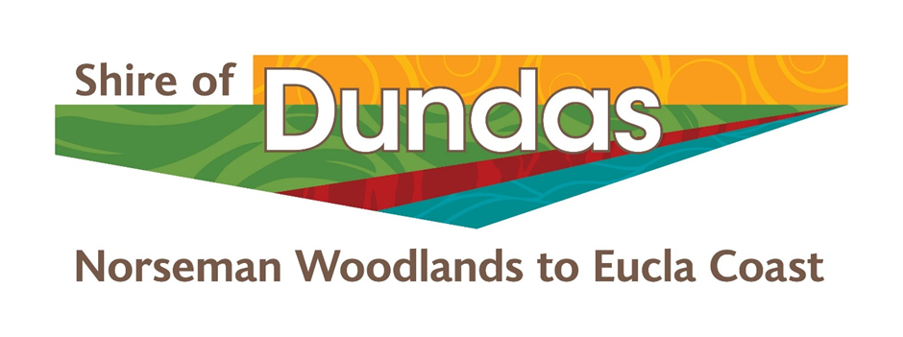

Notice of Meeting and Agenda Notice of Meeting and Unconfirmed Minutes Ordinary Council Meeting19th April 2022

Unconfirmed MINUTES for the ORDINARY Meeting of Council
to be held in the Council Chambers at the Shire Administration Office –
Prinsep Street Norseman on the 19th of April 2022 commencing at 6:00pm AWST

Notes to Unconfirmed Minutes

PLEASE READ THE FOLLOWING IMPORTANT DISCLAIMER BEFORE PROCEEDING:

Any plans or documents in agendas and minutes may be subject to copyright. The express permission of the copyright owner must be obtained before copying any copyright material.

Any statement, comment or decision made at a Council or Committee meeting regarding any application for an approval, consent, or licence, including a resolution of approval, is not effective as an approval of any application and must not be relied upon as such.

Any person or entity who has an application before the Shire must obtain, and should only rely on, written notice of the Shires decision and any conditions attaching to the decision and cannot treat as an approval anything said or done at a Council or Committee meeting.

Any advice provided by an employee of the Shire on the operation of written law, or the performance of a function by the Shire, is provided in the capacity of an employee, and to the best of that person’s knowledge and ability. It does not constitute, and should not be relied upon, as a legal advice or representation by the Shire. Any advice on a matter of law, or anything sought to be relied upon as representation by the Shire should be sought in writing and should make clear the purpose of the request.

Table of Contents
1. Declaration of Opening and Announcement of Visitors. 4
2. Declarations of Financial, Proximity, Impartiality Interests & Gifts Received. 4
3. Record of Attendance of Councillors / Officers and Apologies. 4
4. Applications for Leave of Absence. 4
5. Response to Previous Public Questions Taken on Notice. 4
6. Public Question Time. 4
7. Confirmation of Minutes of Previous Meeting. 5
8. Petitions, Deputations or Presentations. 6
8.1 Reports of Committees 6
8.1.1 GVROC - Cr Bonza/Cr Warner 6
8.1.2 WALGA – Cr Bonza/Cr Patupis 7
8.1.3 Regional Roads Group – Cr Bonza/Cr Wyatt 7
8.1.4Roadwise – Cr Wyatt/Cr Warner 7
9. Announcements by Presiding Member without Discussion. 8
10. Reports 8
Agenda Reference and Subject 8
10.1.1 Fallen Tree on Lot 890 DP205165 - 43 Nulsen Street Norseman 8
10.2 Members and Policy 11
10.2.1 – Receive the Information Bulletin 11
10.2.2 – Council Policy EM.1 Attendance at Conferences and Events 13
10.2.3 – Council Policy F2. Corporate Credit Cards and Store Cards 14
10.2.4 - Attendance at the National General Assembly of the Australian Local Government Association 19-22 June 2022 16
10.3 Administration, Finance and Community Development 18
10.3.1 – Norseman Community Resource Centre Management Report and Financial Statements 18
10.3.2 - Accounts Paid 1st March to 31st March 2022 22
10.3.3 – Financial Statements for the Period Ending 31 March 2022 29
10.4.1 – Officers Reports 57
11. Elected Members Motions of Which Previous Notice Has Been Given 58
11.1 New Business of an Urgent Nature Introduced by the President or by a decision of the Meeting 58
12. Next Meeting 58
13. Closure of Meeting 58

Declaration of Opening and Announcement of Visitors.

The Shire President welcomed all in attendance and declared the meeting open at 6:00 PM

This Ordinary Council Meeting will be video recorded to assist in the preparation of the minutes of the meeting.

1.1 Acknowledgment of Country
The Shire of Dundas recognises the Ngadju and Mirning as First Nations People in the Shire of Dundas, acknowledging them as traditional custodians and pay our respects to their Elders, past, present and emerging.

Declarations of Financial, Proximity, Impartiality Interests & Gifts Received.

Financial Interests: Nil

Proximity Interests: Nil

Impartiality Interests:
10.2.3 Chief Executive Officer
10.2.3 Manager of Corporate and Community Services

Gifts Received by Councillors: Nil
As per the Shire of Dundas Code of Conduct section 3.4 Gifts, adopted by the Council on 21 October 2014 and reference to Regulation 34B of the Local Government (Administration) 1996.

Record of Attendance of Councillors / Officers and Apologies.

Cr LG Bonza Shire President
Cr AR Patupis Deputy Shire President
Cr JEP Hogan
Cr SM Warner
Cr VL Wyatt
Cr J Maloney

Peter Fitchat Chief Executive Officer
Pania Turner Manager of Corporate and Community Services
Latif Samadi Information and Technology Officer

Apologies
Barry Hemopo Acting Manager Works & Services

Public Gallery

Applications for Leave of Absence.

Response to Previous Public Questions Taken on Notice.

Public Question Time.
In accordance with the Local Government Act 1995 and the Local Government (Administration) Regulations 1996, any person may during Public Question Time ask any question. In accordance with Regulation 6 of the Local Government (Administration) Regulations 1996, the minimum time allowed for Public Question Time is 15 minutes.

A member of the public who raises a question during Question Time is to state his or her name and address.

6.1 Topic: Veterinary Clinic Visits in Norseman
Name: Michelle Hindmarsh
Address: 35 Mildura Street, Norseman WA 6443

Can the Shire of Dundas request more frequent veterinary clinic visits to Norseman? Travel to Esperance or Kalgoorlie is a four hour round trip and

Response: Shire President L Bonza

The request is noted; however, the Shire is mindful that the current provider of veterinary services in Norseman travels from Esperance and is a private business; profitability and customer support would be a consideration regarding their number and frequency of visits.

6.2 Topic: Truckstop just past the intersection of Eyre Highway and Coolgardie-Esperance Highway
Name: Des McColl
Address: 34 Brockman Street, Norseman WA 6443

Truck drivers are pulling up at this truck bay (location is roughly 300 metres from the BP heading towards Coolgardie) and using the bush surrounds as a toilet and dumping their rubbish. What is the Shire doing about this problem?

Response: Shire President L Bonza
This problem is being experienced all along the Eyre Highway and the Shire of Dundas has raised similar complaints to Main Roads WA, many times. Eucla has the same issue, and to a much larger extent. We will continue to raise the matter with Main Roads WA.

6.3 Topic: Heritage and Planning
Name: Vivien Dimer
Address: 30 Brockman Street, Norseman WA 6443

Dimer Heritage has identified and listed Scar Trees, which are around Norseman. The Shire is meeting with mining, government/Ministers and Ngadju Native Title and not considering other people in relation to heritage.

What is the Shire doing about Ngadju people’s vehicles be impounded, and police harassment? Ms Dimer stated that she has requested the CEO to organise meetings with the police district headquarters but believes she has not been assisted properly by the Shire.

Response: Shire President L Bonza
In relation to the police and drivers’ licenses, this falls outside the Shire’s jurisdiction.

With regards to the Heritage matters, the Shire does not have jurisdiction to act outside the current system and is required to work with the prescribed body corporate Ngadju Native Title Aboriginal Corporation. The Department of Lands, Planning and Heritage is the State Government department responsible for managing heritage matters. However, the Council will note the feedback regarding Heritage.

Confirmation of Minutes of Previous Meeting.

Minutes of the Ordinary Meeting of Council held on 19th March 2022 be confirmed as a true and accurate record.

Recommendation

7.1 That the minutes of the Ordinary Council Meeting held on 19 March 2022 be confirmed as a true and accurate record.

Moved: Cr. Wyatt
Seconded: Cr. Hogan

Resolution

That the minutes of the Ordinary Council Meeting held on 19 March 2022 be confirmed as a true and accurate record.

Carried by: Simple Majority For: 6 Against: 0

Recommendation

7.2 That the minutes of the Special Council Meeting 1 held on 29 March 2022 at 4pm be confirmed as a true and accurate record.

Moved: Cr. Wyatt
Seconded: Cr. Warner

Resolution

That the minutes of the Special Council Meeting 1 held on 29 March 2022 at 4pm be confirmed as a true and accurate record.

Carried by: Simple Majority For: 6 Against: 0

Recommendation

7.3 That the minutes of the Special Council Meeting 2 held on 29 March 2022 at 4:30pm be confirmed as a true and accurate record.

Moved: Cr. Wyatt
Seconded: Cr. Hogan

Resolution

That the minutes of the Special Council Meeting 2 held on 29 March 2022 at 4:30pm be confirmed as a true and accurate record.

Carried by: Simple Majority For: 6 Against: 0

Petitions, Deputations or Presentations.

8.1 Reports of Committees

8.1.1 GVROC - Cr Bonza/Cr Warner
- Shire of Dundas hosted the GVROC meeting on 1st April
- Dinner was provided the evening before. Our Shire staff did an outstanding job with the set up and the catering. Thanks to our ladies for a fabulous effort.
- Some interesting presentations from Australia’s Golden Outback re: a new tourism development proposal and Tim Neeson on the potential of ‘One Wheel Electric Skateboards’ to engage at risk youth.
- President gave a presentation on things happening around our Shire and as it was April Fool’s Day, we also launched a new housing project. This would see people living in little cave-like dwellings, drilled into the sides of disused mine pits!
- Goldfields Records Storge facility is almost finalised.
- Niki Curtis, our Climate Alliance Coordinator, gave an update on the projects we have chosen to pursue under that funding arrangement and gave us a preview of GVROC’s new website before it went live. The website can be found at www.GVROC.com Details of the proposed projects can be found there.
- The GVROC has signed up to a data sharing platform in partnership with RDAGE.
- A draft of a new strategic plan for GVROC has been presented for comment from each LGA.
- It was proposed that GVROC prepare a submission to the report on Australia’s Regional Strengths and Infrastructure Gaps.
- Next GVROC meeting will be 26th April to consider the State Council agenda for the meeting to be held 4th May.

8.1.2 WALGA – Cr Bonza/Cr Patupis

- State Council will hold an in-person meeting on the 4th May to be hosted by City of Cockburn.
- Matters for decision include a submission to the statutory review of the Food Act 2008, the Local Government Grant Scheme funding, (currently falling below expectations, both in replacement of fire-fighting vehicles and infrastructure), and the draft of the ‘Active Travel to School Roadmap’.
- There will be a Strategic forum held prior to the State Council meeting
- WALGA is continuing advocacy, along with ALGA, on the election campaign, with the theme of “Don’t leave local communities behind”.
- Advocacy on the reform of the Local Government Act 1995, continues.
- Also working on a new road funding agreement as the current agreement expires 2023.

8.1.3 Regional Roads Group – Cr Bonza/Cr Wyatt

- RRG met on 25th March via Teams meeting
- Updates around the roadworks in the region, particularly around the Emu Rocks area which is nearing completion, funding has been secured to finish sealing the Outback Way and there has been a noticeable increase in heavy vehicle movements.
- WALGA is working on a new road funding agreement. An LG group has been established to look at aboriginal employment, recycled materials, road safety and cycling infrastructure. A draft agreement will be presented to State Council.
- The road condition survey has been completed, a final report has been produced and should be available very soon.

8.1.4Roadwise – Cr Wyatt/Cr Warner

8.1.5Local Emergency Management Committee – Cr Bonza/Cr Patupis

- A LEMC meeting was held on 6th April to discuss the pandemic response at a local level.
- Significant effort has been made by the Shire, the Ngadju Rangers, the School, Pantoro and RAM to ensure the safety of our community.
- It has become evident that at a local level, it will be up to us to have plans in place to deal with whatever challenges the pandemic throws up. Fortunately, the aforementioned groups have already taken matters into their own hands and are working in this space.
- The next LEMC meeting will be held on 27th April where we will undertake a desktop airstrip scenario to ensure plans and responses are current and effective.

Announcements by Presiding Member without Discussion.

- President has recently been appointed the Chair of the Grower Group Alliance, SW WA Drought Resilience Adoption, and Innovation Hub Regional Advisory Committee.
- Eight hubs have been created across Australia with funding provided from the Future Drought Fund.
- The basic objectives of this hub are to increase the uptake of drought resilience practices and technologies to improve economic, environmental, and social resilience to drought. And to implement practical applications of research informed by a participatory, place-based approach.
- The scope of the group is quite broad and will take into account, not only drought and drought resilience but, climate change.
- The next meeting will be a workshop which we are hoping to run face-to-face in Carnarvon on 24th or 31st May.

Reports

10.1 Planning, Development, Health and Building

Agenda Reference and Subject

10.1.1 Fallen Tree on Lot 890 DP205165 - 43 Nulsen Street Norseman
Location / Address | Shire of Dundas Region
File Reference | CU.PR2
Author | CEO
Date of Report | 15th April 2022
Disclosure of Interest | Nil

Summary

Mr Kim Wills reported this tree to Council on the 15th April 2021. The tree was standing on Lot no 890/ 45 Nulsen Street. The block belongs to the State Government and is listed as Vacant Crown land. These blocks are maintained by DFES on behalf of the State Government in November every year.

Background

The Shire of Dundas has offered, and tendered, every year to slash and maintain 288 Lots on behalf of the State Government. The cost of maintenance averages approximately $50,000 annually, which equates to be around $170.00 per block and included tree maintenance on the 288 vacant blocks. DFES engage a supplier normally from Northam to tend to these blocks to meet the Bush Fire Regulations, and they do it for about $100.00 per block and don’t tend to any trees.

Statutory Environment

Bush Fire Act 1954
Work Health and Safety Act 2020, that will take effect on 31 March 2022
Dividing Fences Act 1961
Shire of Dundas Planning Scheme

Policy Implications

T.1 Bush Fire Control
T.3 Fencing Control

Financial Implications

The Application will be done by Council staff with assistance from GEDC staff.

Strategic Implications

Theme 3 – Natural & Built Environment
A protected and enhanced environment that is aesthetically pleasing and provides benefits for the Community for generations to come.
Strategy 3 | Goal | Measure | Priority
3.1 Management of environmental impact. | To minimise the impact of Shire activities on the environment. | That any activities undertaken by the Shire have a demonstrable minimal impact on the environment and set a benchmark for the region. | Medium
3.3 Enhanced transport access and infrastructure. | Improved infrastructure within the Shire and good transport access to and around Norseman. | Existing infrastructure that meets Community expectations and requirements.  A measurable improvement in levels of infrastructure. | High
3.4 Enhancement of natural tourist destinations. | Development of the Great Western Woodlands that maintains the overall natural beauty of the area however still provides opportunities for tourism and other uses. | That the GWW is generally preserved and any development undertaken still allows residents and tourists to enjoy its natural beauty  An increased level of tourism numbers visiting the GWW. | Medium/High

Theme 2 – A thriving local economy and economic base
A strong, diversified economy with a number of commercial businesses and industries providing new and varied employment opportunities for all age groups.
Strategy 2 | Goal | Measure | Priority
2.1 Opportunity for Economic Diversification | A vibrant economy that includes opportunities for mining, industry, tourism, shopping and business. | The level and diversity of businesses, including mining, industry, tourism and commercial activity is increasing. | Medium
2.2 Attracting new businesses | New businesses are attracted to the area and existing ones encouraged to grow through promotion of the area as an attractive place to work and live.
2.3 Future Growth and sustainability | Our Shire will maintain the existing population and provide opportunities for future growth for continued sustainability of the Community. | Population levels are stable or increasing to maintain a viable Community. | Medium
2.4 Provide infrastructure that stimulates growth | To assist in the provision of infrastructure that encourages development of existing and new business opportunities. | Increased level of infrastructure that is beneficial to business and industry. | High

Theme 1 – A vibrant, active and healthy socially connected Community
A strong, healthy, educated and connected Community that is actively engaged and involved.
Strategy 1 | Goal | Measure | Priority
1.4 Highly developed educational facilities | A Shire which has highly developed educational opportunities and facilities available to the Community | An increased level of course and career selection available to the Community. | Medium

Consultation

Councillors, Senior Shire Staff and CEO, Department of Planning Lands & Heritage (DPLH)

Comment

Since this incident we have not been able to resolve this issue, we have only been quoted sections of regulations and the State Government has formerly responded back that under the Dividing Fence Act of 1961 they not liable to cover any cost (in papers relation is an email from DPLH).

In response to your email below, please be advised that.
Section 4 of the Dividing Fences Act 1961 states the Crown is not bound by that legislation.
- With regard to the tree falling onto adjacent freehold land (and subsequently causing damage to a boundary fence), Section 264 of the Land Administration Act 1997 applies. Section 264 (2)(a) states in part;

264. Damage emanating from certain Crown land, limited liability of Crown etc. for
(2) Despite any other written law, the liability of the Crown in respect of damage, injury or loss suffered by a person on, or from a cause emanating from —
(a) an unmanaged reserve or unallocated Crown land is limited to damage, injury or loss caused by, or the cause of which is a direct consequence of, an act of the Crown or an activity undertaken by the Crown; or
(b) Crown land which —
(i) is transferred in fee simple, or an interest in which is granted, under this Act; or
(ii) has been disposed of by Crown grant or otherwise under the repealed Act,
does not include liability in respect of damage, injury or loss caused by a hazard or other factor of which warning is given in a statement contained in a memorial a memorandum of which is endorsed under section 17 on the certificate of title or certificate of Crown land title relating to that land.

In light of this, Council must now consider costs to make the fence functional and ensure that the fencing is secure and pet safe. In addition, the ongoing situation has caused stress to the owner, a retiree, and a long-time resident of Norseman. The owner was house bound because of the broken fence as it provides access to the back of the house from the neighbouring vacant block.

These 288 vacant Crown Land Blocks do not contribute to the community rate revenue as legislation allows State and Federal Government not to pay rates, this means that there is no financial contribution in any shape or form to Staff retention, maintenance and/or asset renewal requirements under current legislation.

Voting Requirements

Simple Majority

Officer Recommendation

That the Shire of Dundas Council consider the following:
- Delegate the CEO to work with the owner of 43 Nulsen Street to get his fence repaired.
- For Elected Members and CEO to continue lobbying Local Members of Parliament to assist with this matter and have the cost of this repair covered by the State Government.
Moved | Cr: Wyatt
Seconded | Cr: Warner

Resolution

- Delegate the CEO to work with the owner of 43 Nulsen Street to get his fence repaired.
- For Elected Members and CEO to continue lobbying Local Members of Parliament to assist with this matter and have the cost of this repair covered by the State Government.

Carried by: | Simple Majority | For: | 6 | Against | 0

10.2 Members and Policy

Agenda Reference & Subject

10.2.1 – Receive the Information Bulletin
Location / Address | Shire of Dundas
File Reference | PE.ME.2
Author | Chief Executive Officer - Peter Fitchat
Date of Report | 12 April 2022
Disclosure of Interest | Nil

Summary

For Council to consider receiving the Information Bulletin for 31 March 2022.

Background

The Councillors’ Information Bulletin for the period ending 31 March 2022 was completed and circulated to Councillors.

Statutory Environment

Local Government Act 1995

- Section 2.7(2) - Provides that Council is to oversee the allocation of local government finances and resources and to determine the local government policies.

- Section 3.1 – Provides that the general function of the local government is to provide for the good governance of persons in its district.

Policy Implications

Council has no policies in relation to this matter.

Financial Implications

The recommendation of this report has no financial implications for Council.

Strategic Implications
Informing Elected Members with respect to matters impacting on their roles, responsibilities and decision- making as the Shire of Dundas Council.

Consultation
The IB Report is prepared in consultation with Senior Officers

Comment

The intent of the Councillors’ Information Bulletin is to assist in providing Councillors with information relevant to their role as a Councillor.

The Information Bulletin contains confidential elements and is not a public document, it is distributed to Councillors and senior officers only and is not for public release.

Voting Requirements
Simple Majority

Officer Recommendation

That Council receive the monthly Councillors’ Information Bulletin for the period ending 31 March 2022 as included in confidential papers relating.

Moved: Cr. Wyatt
Seconded: Cr. Hogan

Resolution

That Council receive the monthly Councillors’ Information Bulletin for the period ending 31 March 2022 as included in confidential papers relating.

Carried by: Simple Majority For: 6 Against: 0

Agenda Reference & Subject

10.2.2 – Council Policy EM.1 Attendance at Conferences and Events
Location / Address | Shire of Dundas
File Reference | GV.PO.1
Author | Manager of Corporate and Community Services – Pania Turner
Date of Report | 12 April 2022
Disclosure of Interest | Nil

Summary

For the Council of the Shire of Dundas to review and endorse the updated Attendance at Conferences and Events Policy.

Background

From time to time elected members and senior staff are required to attend events in their role as a representative of the Shire of Dundas. Approval for attendance at events should take into consideration the nature and extent of the event and the value and benefit it will bring to the bettering the outcomes for community of the Shire of Dundas.

Additionally, due to the nature of a local government’s business, elected members and employees may from time to time may be offered tickets to attend events providing opportunity to work and network with stakeholders to legitimately further the interests of the Shire of Dundas and its community.

Having a policy in place will provide a framework for the acceptance of tickets to events by elected members and employees and to actively consider the purpose of and benefits to the community in attending. The policy will also detail what disclosure requirements are needed when attending events by elected members and employees and a range of other governance arrangements when attending events.

Statutory Environment
The purpose of this policy is to comply with the requirements of section 5.90A of the Local
Government Act 1995 and the Shire’s Code of Conduct.

Policy Implications

Update of existing Policy EM.1 Conferences – Elected Members Attendance and Representation

Financial Implications

Attendance at events will follow the required purchasing procedures and disclosure requirements.

Strategic Implications

A clear policy on attendance at events will ensure that attendance will benefit community of the Shire of Dundas and meet the objectives identified in the Strategic Community Plan.

Consultation
Senior Officers

Comment

The policy has been reviewed to ensure that Shire of Dundas is represented at the appropriate international, national and interstate conferences, study tours, seminars, conventions and events.

The policy now takes into account the gift of tickets to conference and events.

Voting Requirements
Absolute Majority

Officer Recommendation
That the Shire of Dundas Council endorse the revised Policy EM.1 Attendance at Conferences and Events.

Moved | Cr: Warner
Seconded | Cr: Hogan

Resolution

That the Shire of Dundas Council endorse the revised Policy EM.1 Attendance at Conferences and Events.

Carried by: | Absolute Majority | For: | 6 | Against | 0

Agenda Reference & Subject

10.2.3 – Council Policy F2. Corporate Credit Cards and Store Cards
Location / Address | 88-92 Prinsep Street, Norseman WA 6443
File Reference | FM.PO.1
Author | Manager of Corporate and Community Services – Pania Turner
Date of Report | 14 April 2022
Disclosure of Interest | Impartiality:  The following staff are allocated a corporate credit card:  - Chief Executive Officer  - Manager of Corporate & Community Services  - Manager of Works and Services

Summary

For the Council of the Shire of Dundas to consider and approve the revised policy F2 Corporate Credit Cards.

Background

The Corporate Credit Cards and Store Cards Policy has been updated to accommodate staffing changes and to improve operational purchasing procedures.

Statutory Environment
Local Government Act 1995, Local Government (Functions and General) Regulations 1996
State Records Act 2000

Policy Implications

Update of Policy F.2

Financial Implications

Regular review of the purchasing and procedures ensures the Shire of Dundas purchasing activities and decision making, are of a high standard and allow for operational efficiency while ensuring transparency, best value for money that considers strategic priorities and benefits.

Strategic Implications

N/A

Consultation
Senior Officers

Comment

The Policy updates include:
- Increase of the Shire of Dundas collective credit card limit from $10,000 to $20,000
- Removal of store cards
- increase of credit card limit to $4000 for the Manager of Corporate and Community Services, and the Manager of Works and Services;
- credit card authority of up to $1500 for the Tourism and Events Officer, and the Senior Administration Officer;

Voting Requirements
Absolute Majority

Officer Recommendation

That the Shire of Dundas Council:
- authorise the increase of Shire’s Corporate Credit Cards collective limit to $20,000; and
- endorse the revised Policy F2. Corporate Credit Cards.

Moved: Cr. Wyatt
Seconded: Cr. Hogan

Resolution

That the Shire of Dundas Council:
- authorise the increase of Shire’s Corporate Credit Cards collective limit to $20,000; and
- endorse the revised Policy F2. Corporate Credit Cards.

Carried by: Absolute Majority For: 6 Against: 0

Agenda Reference & Subject

10.2.4 - Attendance at the National General Assembly of the Australian Local Government Association 19-22 June 2022
Location / Address | 88-92 Prinsep Street, Norseman WA 6443
File Reference | GR.SL.25
Author | Manager of Corporate and Community Services – Pania Turner
Date of Report | 13 April 2022
Disclosure of Interest | Nil

Summary

For the Council of the Shire of Dundas to consider and appoint Shire of Dundas delegates at National General Assembly of the Australian Local Government Association 19-22 June 2022.

Background

The 2022 Australian Local Government Association (ALGA) National General Assembly (NGA)
will be held in Canberra from 19 to 21 June 2022. This important event provides opportunity for Local Government to engage directly with the Federal Government, to develop national policy, and to influence the future direction of our councils and our communities.

ALGA is national voice of local government representing Australian local governments at the national level. ALGA provides important advocacy across many areas critical to local government and communities including local roads and infrastructure resourcing, disaster mitigations funding, regional airports and airstrips, telecommunications, social disadvantage, climate change and more.

The theme for the 2022 General Assembly is Partners in Progress, focusing on how strong partnerships,
particularly between the Australian Government and local government can be used to address the many
challenges communities are faced with.

Statutory Environment
Nil

Policy Implications

Policy EM.1 Conferences – Elected Members Attendance and Representation (noting that this may be the updated Policy EM.1 Attendance at Conference and Events)

Financial Implications

The budget required for the two elected members and a Shire Officer for 6 days is approximately $15,000.
The approved 2021-2022 budget can accommodate this cost.

Registration  (per delegate) | Travel & Accommodation  (per delegate) | Meals & Incidentals  (per delegate)
Early bird registration $989  Virtual Attendance $689  Additional Regional Forum: $425 | Accommodation $200-$240 per night  Flights: $1000-1200  Additional Travel for the group taxis/uber/ hire car: $200-$800 | Networking Dinners and events: $375  Meals: $400

Strategic Implications

Representation at State and National platforms is essential for the Shire of Dundas to ensure that small local governments such as the Shire of Dundas are resourced and supported to achieve the strategic objectives of their community plans.

Theme 2 – A thriving local economy and economic base
A strong, diversified economy with a number of commercial businesses and industries providing new and varied employment opportunities for all age groups.
Strategy 2 | Goal | Measure | Priority
2.1 Opportunity for Economic Diversification | A vibrant economy that includes opportunities for mining, industry, tourism, shopping and business. | The level and diversity of businesses, including mining, industry, tourism and commercial activity is increasing. | Medium
2.2 Attracting new businesses | New businesses are attracted to the area and existing ones encouraged to grow through promotion of the area as an attractive place to work and live.
2.3 Future Growth and sustainability | Our Shire will maintain the existing population and provide opportunities for future growth for continued sustainability of the Community. | Population levels are stable or increasing to maintain a viable Community. | Medium
2.4 Provide infrastructure that stimulates growth | To assist in the provision of infrastructure that encourages development of existing and new business opportunities. | Increased level of infrastructure that is beneficial to business and industry. | High

Consultation
Elected Members
Senior Officers
WALGA

Comment

The Attendance at Conferences and Events Policy has been reviewed to ensure that Shire of Dundas is represented at the appropriate international, national and interstate conferences, study tours, seminars, conventions and events.

The Shire of Dundas has proposed, through WALGA, motions regarding disaster mitigation funding, and the Financial Assistance Grant. Having local governments across Australia contribute to motions at the National General Assembly informs ALGA’s strategic direction and national advocacy objectives, raises awareness of the issues faced by communities to federal Ministers, Members of Parliament and key stakeholders in Canberra.

The appointment of Shire of Dundas Council delegates to attend the 2022 National
General Assembly will also provide important opportunity for the Council to meet with Federal Ministers to discuss key areas of concern for the Shire of Dundas, including the impact of climate change and drought in the Shire of Dundas, initiatives to address the critical housing shortage and regional communities, including Norseman, disaster mitigation funding, and the Financial Assistance Grant.

Voting Requirements
Simple Majority

Officer Recommendation

That the Shire of Dundas Council:
- nominate the Shire President Cr. L Bonza and Cr. Warner as delegates to attend the 2022 Australian Local Government Association National General Assembly
in Canberra;
- authorise the Chief Executive Officer, or appointed Senior Officer, to accompany the councillor delegates to provide executive support; and
- approve a budget of up to $15,000 for attendance at the 2022 Australian Local Government Association National General Assembly.

Moved: Cr. Hogan
Seconded: Cr. Wyatt

Resolution

That the Shire of Dundas Council:
- nominate the Shire President Cr. L Bonza and Cr. Warner as delegates to attend the 2022 Australian Local Government Association National General Assembly
in Canberra;
- authorise the Chief Executive Officer, or appointed Senior Officer, to accompany the councillor delegates to provide executive support; and
- approve a budget of up to $15,000 for attendance at the 2022 Australian Local Government Association National General Assembly.

Carried by: Simple Majority For: 6 Against: 0

10.3 Administration, Finance and Community Development

Agenda Reference & Subject

10.3.1 – Norseman Community Resource Centre Management Report and Financial Statements
Location / Address | Shire of Dundas
File Reference | CS.SP.8
Authors | Norseman Community Resource Manager, Angela Hogan  Senior Administration Officer, Ciara Stewart
Date of Report | 12 April 2022
Disclosure of Interest | Nil

Summary

That the Shire of Dundas Council review and accept the Norseman Community Resource Centre Management Report and Financial Statements for the period ending 31 March 2022.
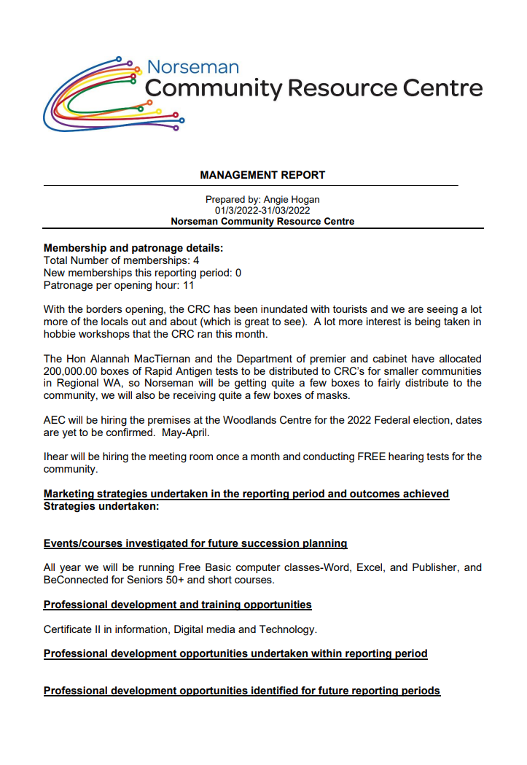

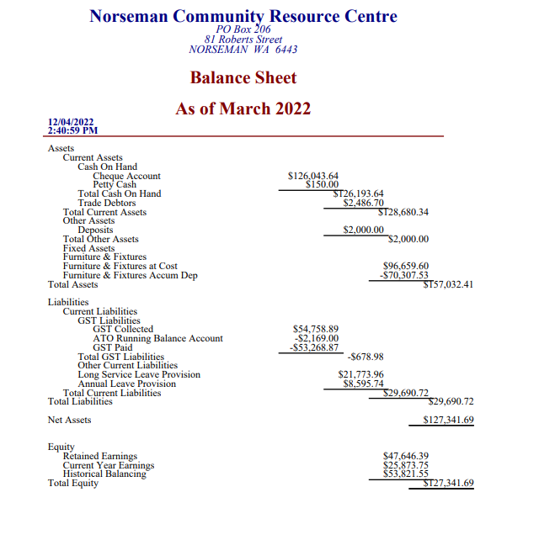

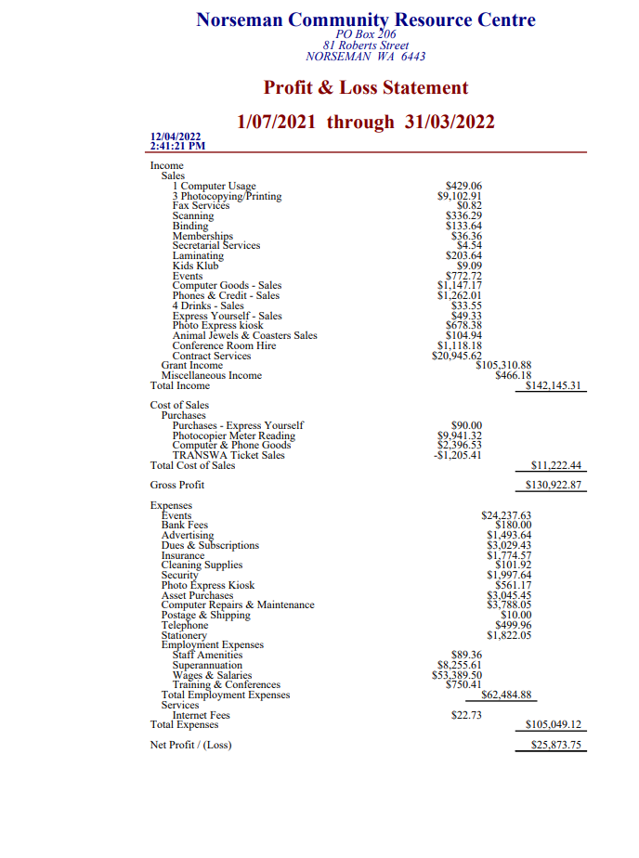
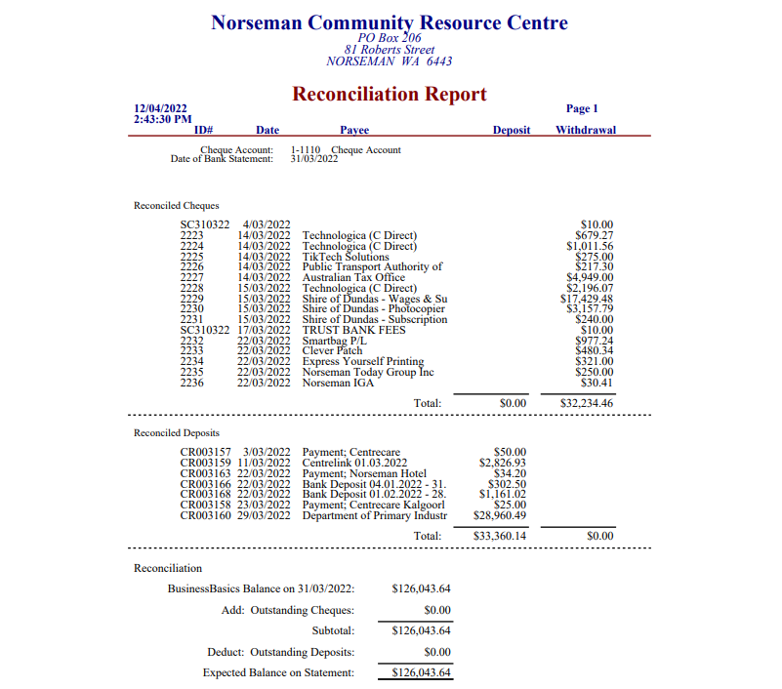

Consultation
Manager Norseman Community Resource Centre
Shire of Dundas Manager of Corporate and Community Services
Shire of Dundas Senior Administration Officer

Voting Requirements
Simple Majority

Officer Recommendation
That the Norseman Community Resource Centre Management Report and Financial Statements for the period ending 31 March 2022 be accepted.

Moved | Cr: Wyatt
Seconded | Cr: Hogan

Resolution

That the Norseman Community Resource Centre Management Report and Financial Statements for the period ending 31 March 2022 be accepted.

Carried by: | Simple Majority | For: | 6 | Against | 0

Agenda Reference & Subject

10.3.2 - Accounts Paid 1st March to 31st March 2022
Location / Address | Shire of Dundas
File Reference | FM.CR
Author | Accounts Officer, Ali Sherifi
Date of Report | 12 April 2022
Disclosure of Interest | Nil

Summary

For Council to review and note the operational expenditure and accounts paid 1st March to 31st March 2022.

Statutory Environment
Local Government Act 1995

Policy Implications
Council has approved policies and procedures in place to ensure that the monthly accounts are approved and paid with due diligence.

Financial Implications
Accounts are managed within the approved Budget.

Trust Payments
Chq/EFT | Date | Name | Description | Amount
563 | 22-03-2022 | Shire Of Dundas Petty Cash | RECOUP PETTY CASH 25.10.2021 - 22.03.2022 | 550.00
 |  |  |  | $550.00

Municipal Cheques
Cheque | Date | Name | Description | Amount
26400 | 10-03-2022 | Shire Of Dundas | CASH WITHDRAWAL - NORSEMAN CUP DINO RACES | 750.00
26401 | 22-03-2022 | Shire Of Dundas Petty Cash | Recoup To Petty Cash 25.10.2021 - 22.03.2022 | 351.25
 |  |  |  | $1,101.25

Municipal Account EFT’s
EFT | Date | Name | Description | Amount
EFT6312 | 04-03-2022 | Australia Post | Postage (January 2022) | 194.02
EFT6313 | 04-03-2022 | ATOM SUPPLY | Camlocks, Cap Star Picket And Out Of Service Tages For Norseman Hyden Road | 710.60
EFT6314 | 04-03-2022 | Bonza Constructions Pty Ltd | Fit Drop Hooks To Gates At Woodlands Centre, Supply Bobcat To Drill Post Holes And Materials $827.06  Unblock Toilets At Phoenix Park – Blockage Due To Vandalism $198 | 1025.06
EFT6315 | 04-03-2022 | Bunnings Warehouse Kalgoorlie | Various Supplies For Eucla / Hyden Norseman Road Work $2175.76  Credit Note – Concrete Rapid Set Swan 20kg -$221.70 | 1954.06
EFT6316 | 04-03-2022 | FULL MOON CAFE | Catering For Traffic Management Training 14th, 15th & 16th February $1150.  Catering Sandwiches And Fruits For 8 People $120 | 1270.00
EFT6317 | 04-03-2022 | STITCH AND GIFT | Gold Spoons For Name Badges (Mining Expo 13th October 2021) | 300.00
EFT6318 | 04-03-2022 | Horizon Power | Various Power Charges - 16.12.2021 - 15.02.2022 | 18311.26
EFT6319 | 04-03-2022 | Golden Flame Nominees Pty Ltd | 42 Bags Of ICE For The Outside Crew February 2022 | 126.00
EFT6320 | 04-03-2022 | Navman Wireless Australia Pty Ltd | Monthly Satellite Service (05.02.2022 - 03.02.2022) | 65.89
EFT6321 | 04-03-2022 | Royal Life Saving Society WA Inc | Registration - 3 Years And Purchase 1x Large Floor Mat | 1001.22
EFT6322 | 04-03-2022 | Wilsons Diesel & Auto Repairs | 2 X New Tyre For Holden Colorado P327 DS232 | 626.40
EFT6323 | 04-03-2022 | SHARON MAREE WARNER | Return Travel To Esperance For GVROC Meeting On 04.02.2022 | 396.04
EFT6324 | 08-03-2022 | VANESSA AUSTRALIA | Visitor Centre Restock Vanessa Australia Display $2169.55  Credit Note – Visitor Centre Restock -$1120.88 | 1048.67
EFT6325 | 08-03-2022 | AUSCOINSWEST | 500 X Souvenir Coins, 5x Coins Collectors Albums And Postage & Handling For The Visitor Centre | 628.10
EFT6326 | 11-03-2022 | Eucla Motor Hotel | Accommodation & Meals For Tony Dowling (Town Planning) | 256.50
EFT6327 | 11-03-2022 | ATOM SUPPLY | 2 X Camlock Aluminum 2.5-Inch Hose 65mm For Hyden Road Works | 46.20
EFT6328 | 11-03-2022 | BUNNINGS GROUP LIMITED | Various Reticulation Supplies | 416.22
EFT6329 | 11-03-2022 | Building & Construction Industry Training Fund | Recoup To BCITF | 591.75
EFT6330 | 11-03-2022 | Cuten Guneder Machinery | Pump Out Dump Point At Welcome Park $880  Pump Out Sewage At Dog Pound $300 | 1180.00
EFT6331 | 11-03-2022 | Department Of Human Services (Child Support) | Payroll Deductions | 359.99
EFT6332 | 11-03-2022 | Shire Of Dundas | Commission - Building Levy Lot 871 51 Richardson Street | 8.25
EFT6333 | 11-03-2022 | Elite Gym Hire | Hire Of Weights 12.02.2022 - 12.03.2022 $568.65  Hire Of Treadmill, Bike, Rower & Cross Trainer (12.02.2022 – 12.03.2022) $442.70 | 1011.35
EFT6334 | 11-03-2022 | FULL MOON CAFE | Catering For Council Meeting 22.02.2022 | 400.00
EFT6335 | 11-03-2022 | Glen Flood Group Pty Ltd T/A GFG Consulting | BCA Compliance Review 3d Printed Homes - Professional Services/Certification For Development 21st January 2022 $3942.40  Health Surveyor – Ruth Levitt Ram Tavern, Caiguna Roadhouse 6.5 Hours @$129/Hr 7.02.2022 – 20.02.2022 $922.35 | 4864.75
EFT6336 | 11-03-2022 | GEONEON PTY LTD | 25% Deposit For Vegetation And Infrastructure Identification And Exposure And Vulnerability Analysis | 16390.00
EFT6337 | 11-03-2022 | Horizon Power | Streetlights - 01.02.2022 - 28.02.2022 | 4843.87
EFT6338 | 11-03-2022 | Landgate | Mining Tenement Chargeable Schedule No. M2021/2 Date 28.01.2022 - 04.02.2022 | 58.45
EFT6339 | 11-03-2022 | CS Legal Lawyers | Debt Recovery February 2022 | 460.40
EFT6340 | 11-03-2022 | Moore Australia (WA) Pty Ltd | 2022 Budget Review And Preparation, Compilation Of 2021 WA LG Grants Commission Information Return, Assistance With Preparation Of LRCI Phase 2 Report $6858.50  Compilation Of EO Review To CEO For Period Ending 31 January 2022 $2475 | 9333.50
EFT6341 | 11-03-2022 | Norseman General Practice | Pre-Employment Medical For Paul Stewart - 22.02.2021 | 154.00
EFT6342 | 11-03-2022 | VEECO LAUNDRY SYSTEMS | Final 80% On Laundry System Install | 171131.10
EFT6343 | 11-03-2022 | SHARON MAREE WARNER | Standby Pool Manager - 19 Hours From 13.02.2022 To 27.02.2022 @$50/Hr | 950.00
EFT6344 | 18-03-2022 | Australian Taxation Office | BAS (FEBRUARY 2022) | 13349.00
EFT6345 | 18-03-2022 | ATOM SUPPLY | Suction Water Line Hose And Clamps X8 For The Depot | 438.68
EFT6346 | 18-03-2022 | BP Norseman | Diesel & Unleaded Fuel Purchases February 2022 | 517.63
EFT6347 | 18-03-2022 | BOC Limited | Container Service Fee (29.01.2022 - 25.02.2022) | 38.29
EFT6348 | 18-03-2022 | Department Of Human Services (Child Support) | Payroll Deductions | 359.99
EFT6349 | 18-03-2022 | Esperance Communications | Lost Network - Checked For Configuration, Rebooted Access Point, And Tested All Okay | 65.00
EFT6350 | 18-03-2022 | Esperance Rural Supplies | 12 Bags Baileys Energy 1317 Fertilizer | 640.20
EFT6351 | 18-03-2022 | Department Of Fire & Emergency Services | ESL (FEBRUARY 2022) | 2051.12
EFT6352 | 18-03-2022 | FULL MOON CAFE | Catering For The Machinery & White Card Training For Outside Crew 1st-4th Of March 2022 | 1000.00
EFT6353 | 18-03-2022 | Goldfields Image Works | Interior & Exterior Wall Panorama, Mounted Canvas Dellisser Dunes & Mounted Canvas Mile Granites For President's Office | 5962.00
EFT6354 | 18-03-2022 | Great Northern Tree Lopping | Various Tree Pruning In Norseman Streets | 13100.00
EFT6355 | 18-03-2022 | HARVEY NORMAN AV/IT KALGOORLIE | 1 X Huon Cherry Bookcase, 1 X Executive Desk Large, 4 Draw Filing Cabinet & Freight | 1977.01
EFT6356 | 18-03-2022 | KALGOORLIE REFRIGERATION | Install Replacement New Split Air Conditioner To Gym Plus Labor And Materials $3200  Repaired Air-Conditioning At Admin Building Plus Travel And Labour $1274.90 | 4474.90
EFT6357 | 18-03-2022 | MARKET CREATIONS AGENCY | Trailer Graphic: Shire Of Dundas Email Signature Design | 451.00
EFT6358 | 18-03-2022 | Marketforce | Advertising - Executive Assistant (West Australian 19.02 & 23.02) $1339.38  Advertising Executive Assistant (Kal Miner 19.02 & 23.02.2022) $648.34 | 1987.72
EFT6359 | 18-03-2022 | Microshel Family Trust T/AS PACK & SEND EAST PERTH RGSMW PTY LTD | Freight - RSEA | 391.18
EFT6360 | 18-03-2022 | PREMIUM PUBLISHERS | AGO Holiday Planner 2022 Norseman To Nullarbor Content | 1842.50
EFT6361 | 18-03-2022 | South East Petroleum | Diesel 7,500 Liters | 12489.68
EFT6362 | 18-03-2022 | Solutions IT (Invoice S + B) | Agreement - Managed Support (Monthly Billing March 2022) | 2470.44
EFT6363 | 18-03-2022 | SHARON MAREE WARNER | Standby Pool Manager 28.02.2022 - 13.03.2022 12 Hours @$50/Hr | 600.00
EFT6364 | 18-03-2022 | Telstra Corporation Limited | Phone & ADSL Charges 04.03.2022 - 04.04.2022 $1306.69  ADSL Charges For 16.03.2022 – 15.04.2022 $195.60  Telstra 4GXWIFI PLUS For CEO $44.06 | 1546.35
EFT6365 | 23-03-2022 | HARVEY NORMAN AV/IT KALGOORLIE | Purchase Zenith Lounge (1x 2-Seater & 1x 3-Seater) For President's Office | 4548.00
EFT6366 | 25-03-2022 | Asphalt In A Bag Pty Ltd | 50x 20KG Bags Of Asphalt | 2194.41
EFT6367 | 25-03-2022 | Zircodata Pty Ltd | Storage Of Registers (26.01.2022 - 25.02.2022) | 160.24
EFT6368 | 25-03-2022 | BUNNINGS GROUP LIMITED | Various Items For The Depot And Hyden Norseman Road Works | 926.98
EFT6369 | 25-03-2022 | BE Stearne & Co Pty Ltd | Various Reticulation Supplies | 47.90
EFT6370 | 25-03-2022 | Bonza Constructions Pty Ltd | Misc Repairs To The Building, Primer And Painting Applied, Source & Supply Materials Plus Labor At The Laundromat | 8536.00
EFT6371 | 25-03-2022 | Laurene Bonza | President Allowance March 2021 $1326  Claim (Council Meeting 19.03.2022), IB Session 08.03.2022 $481 | 1807.00
EFT6372 | 25-03-2022 | Cutting Edges Pty Ltd | 1x Grader Blade, 2 X Plow Bolt, 3 X Plow Bolt Nut For CAT Grader P279  $3073.84  Purchase Of Grader Blades And Plow Bolts For Grader $582.01 | 3655.85
EFT6373 | 25-03-2022 | COASTLINE MOWERS | Sundry Tool For Mower | 200.00
EFT6374 | 25-03-2022 | Dundas Fencing & Building Maintenance | Pump Out Sceptics At Welcome Park | 721.05
EFT6375 | 25-03-2022 | BJ DOWELL AND SL FLYNN-DOWELL PTY LTD Q | Fabricate Frame To Accommodate Canvas Canopy And Solar Panel & Accommodate For Animal Transportation | 3905.00
EFT6376 | 25-03-2022 | FULL MOON CAFE | Catering For Council Workshop 01.03.2022 | 200.00
EFT6377 | 25-03-2022 | Global Communication Services | 1 X 5W 80CH CB H/HELD TWIN PACK UHF & Accessories Plus Freight | 543.98
EFT6378 | 25-03-2022 | Goldfields Voluntary Regional Organisation Of Council | Annual Contribution 2021/2022 | 16500.00
EFT6379 | 25-03-2022 | DOWLING GIUDICI ASSOCIATES | As Per DG+A Professional Services Agreement 201218 40hrs At $95/Hr. | 4180.00
EFT6380 | 25-03-2022 | John Edward Patrick Hogan | Claim (Council Meeting - 19.03.2022), IB Session 08.03.2022 | 318.00
EFT6381 | 25-03-2022 | P & L Hogan Services | 2 X 45kg Gas Bottles For 139 Robert Street On 03.02.2022 | 340.00
EFT6382 | 25-03-2022 | JOHN MALONEY | Claim (Council Meeting - 19.03.2022), IB Session 08.03.2022 | 318.00
EFT6383 | 25-03-2022 | CR KENNEDY & CO PTY LTD | 1 X Reveal D5 Body Camera Including Dems Software License Bundle For Ranger Services | 1430.00
EFT6384 | 25-03-2022 | Landgate | Certificate Of Title 1041/980 For The Men’s Shed | 27.20
EFT6385 | 25-03-2022 | Mcleods Barristers & Solicitors | Safety Of Local Government Volunteer Bush Fire Brigades $1513.59  Crown Liability For Fallen Trees Onto Adjacement Land, Preparing Advice Setting, Crown Liability For Fallen Trees $952.98 | 2466.57
EFT6386 | 25-03-2022 | OFFICE OF THE AUDITOR GENERAL | Fee For The Certification Of Roads To Recovery Funding For The Year Ended June 2021 | 880.00
EFT6388 | 25-03-2022 | Shenton Pumps | Delivery Of Loan Cleaner For The Swimming Pool $1228.27  Replace Belts And Brushes For The Loan Machine At The Swimming Pool $1069.20 | 2297.47
EFT6389 | 25-03-2022 | Microshel Family Trust T/AS PACK & SEND EAST PERTH RGSMW PTY LTD | Freight - Corsign Pty Ltd $554.19  Coastline Mowers - $88.76 | 642.95
EFT6390 | 25-03-2022 | QTM PTY LTD | Coolgardie-Esperance Hwy Norseman Event Traffic Management Plan Development | 1188.00
EFT6391 | 25-03-2022 | SEEK LIMITED | Advertising - Executive Assistant | 324.50
EFT6392 | 25-03-2022 | STABILISATION TECHNOLOGY PTY LTD | Pavement Investigation And Engineering Services For Norseman Airstrip Plus Travel $4433  Soil Testing – Ecula Airstrip $2047.10 | 6480.10
EFT6393 | 25-03-2022 | Wilsons Diesel & Auto Repairs | 2 X Batteries For Toyota Coaster Bus P306 1GBF296 | 531.00
EFT6394 | 25-03-2022 | SHARON MAREE WARNER | Claim (Council Meeting - 19.03.2022), IB Session 08.03.2022 | 318.00
PAY | 01-03-2022 | PAYROLL | Payroll Direct Debit Of Net Pays Payroll Direct Debit Of Net Pays | 65,055.67
7226 | 03-03-2022 | Daryl Glover | Reimbursement - BRPC Expenses | 97.36
7230 | 07-03-2022 | Bank Fees | Centrepay Fee - A771 | 0.99
7233 | 08-03-2022 | Bank Fees | Centrepay Fee - A698 | 0.99
7244 | 14-03-2022 | Bank Fees | Centrepay Fee - A525 | 0.99
PAY | 15-03-2022 | PAYROLL | Payroll Direct Debit Of Net Pays Payroll Direct Debit Of Net Pays | 90,952.97
7254 | 18-03-2022 | Daryl Glover | Reimbursement - BRPC Expenses | 142.48
7259 | 21-03-2022 | Bank Fees | Centrepay Fees - A771 | 0.99
7263 | 21-03-2022 | Leigh Morgan | Reimbursement For Citizenship Frame For Eucla | 22.35
7278 | 28-03-2022 | Bank Fees | Centrepay Fee - A525 | 0.99
PAY | 29-03-2022 | PAYROLL | Payroll Direct Debit Of Net Pays Payroll Direct Debit Of Net Pays | 60,764.68
 |  |  |  | $588,595.00

Municipal Account Direct Debts
 | Date | Name | Description | Amount
7222 | 01-03-22 | Bank Fees | ANZ Merchant Fee | 290.19
7228 | 07-03-22 | ANZ BPAY | BPAY Transaction Fee | 37.13
7247 | 15-03-22 | 3E Advantage Pty Limited | CRC Photocopier, Shire Photocopier & Printer Meter Readings – 01.03.2022 – 31.03.2022 | 3549.70
 |  |  |  | $3,877.02

Municipal Account Credit Cards
Chq/EFT | Date | Name | Description | Amount
7269 | 18/03/2022 | Chief Executive Officer | ANZ Credit Card Purchases 24.01.2022 – 21.02.2022
 | 20-01-22 | Full Moon Café | Budget Meeting Expenses | 17.50
 | 24-01-22 | Great Western Norseman | Dinner For Tony Dowling Town  Planning | 56.00
 | 25-01-22 | Full Moon Café | Catering For OASG Meeting | 40.50
 | 27-01-22 | Adobe | Subscription | 21.99
 | 28-01-22 | Doodly | Subscription | 101.21
 | 01-02-22 | Linkedin | Subscription | 39.99
 | 01-02-22 | Myob | Subscription | 120.00
 | 02-02-22 | Movavi | Subscription | 56.14
 | 04-02-22 | Comfort Inn Bay | GVROC Meeting In Esperance (Meals For Councillors) | 65.00
 | 04-02-22 | Comfort Inn Bay | Accommodation For Councillors - GVROC Meeting In Esperance | 510.30
 | 11-02-22 | Full Moon Café | Catering For GVROC | 39.50
 | 11-02-22 | Tara Treasures | Retail Stock Purchases For Visitor Centre | 590.05
 | 12-02-22 | Adobe | Subscription (Additional) | 24.99
 | 17-02-22 | State Law Publishers | Town Planning (Local Planning Scheme 2) | 457.20
 | 18-02-22 | Full Moon Café | Catering For GVROC | 29.50
 |  |  |  | $2,169.87

7268 | 18/03/2022 | Community Development Officer | ANZ Credit Card Purchases 24.01.2022 – 21.02.2022
 | 07-02-22 | Office National Kalgoorlie | Stationery For The Office | 156.69
 | 11-02-22 | Temple & Webster St Peters | Office Equipment And Chair For The President Office | 1547.62
 |  |  |  | $1,704.31

Summary Of Account Totals
Trust EFT’s / Cheques | $550.00
Municipal Cheques | $1,101.25
Municipal EFT’s | $588,595.00
Municipal Direct Debit’s | $3,877.02
Municipal Credit Card’s | $3,874.18
Grand Total For March 2022 | $597,997.45

Voting Requirements

Simple Majority

Officer Recommendation

That the Shire of Dundas monthly accounts paid from 1st March 2022 to 31st March 2022 be noted.

Moved: Cr. Wyatt
Seconded: Cr. Hogan

Resolution

That the Shire of Dundas monthly accounts paid from 1st March 2022 to 31st March 2022 be noted.

Carried by: | Simple Majority | For: | 6 | Against | 0

Agenda Reference & Subject

10.3.3 – Financial Statements for the Period Ending 31 March 2022
Location / Address | Shire of Dundas
File Reference | FM.F1
Author | Moore Australia
Date of Report | 13 April 2022
Disclosure of Interest | Nil

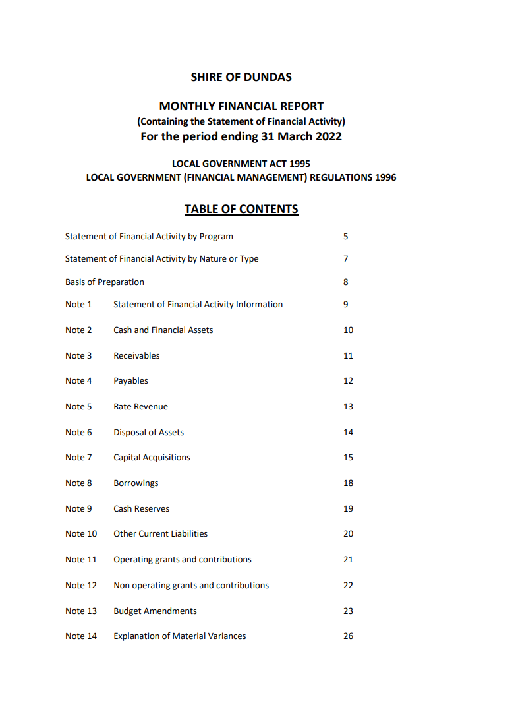

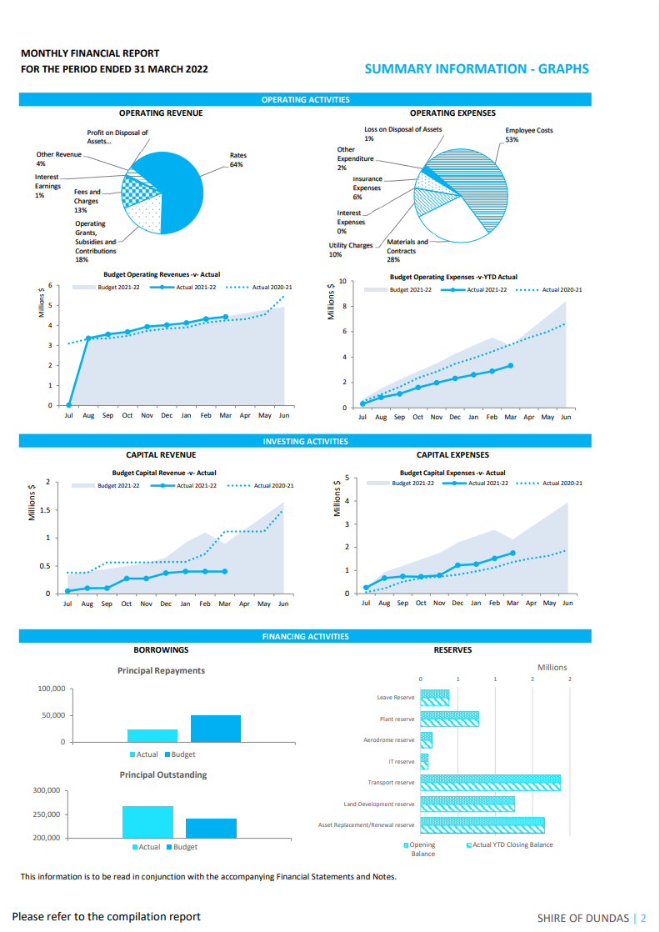
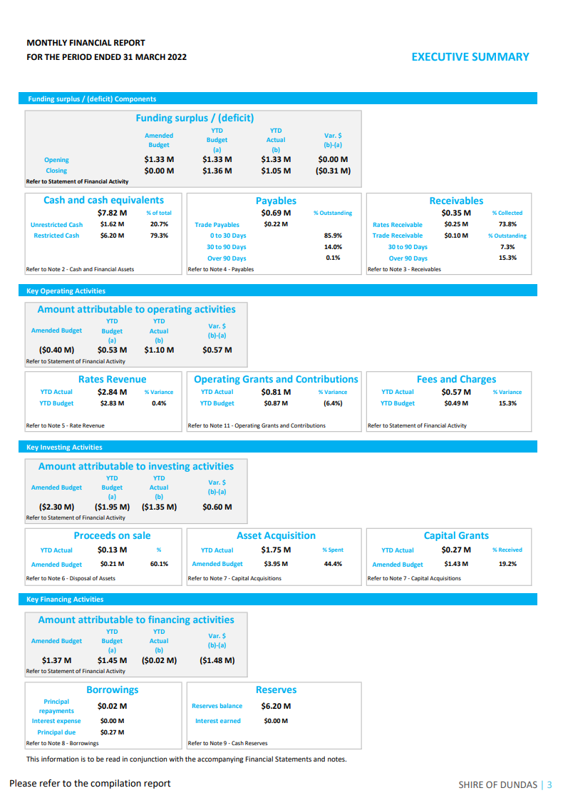
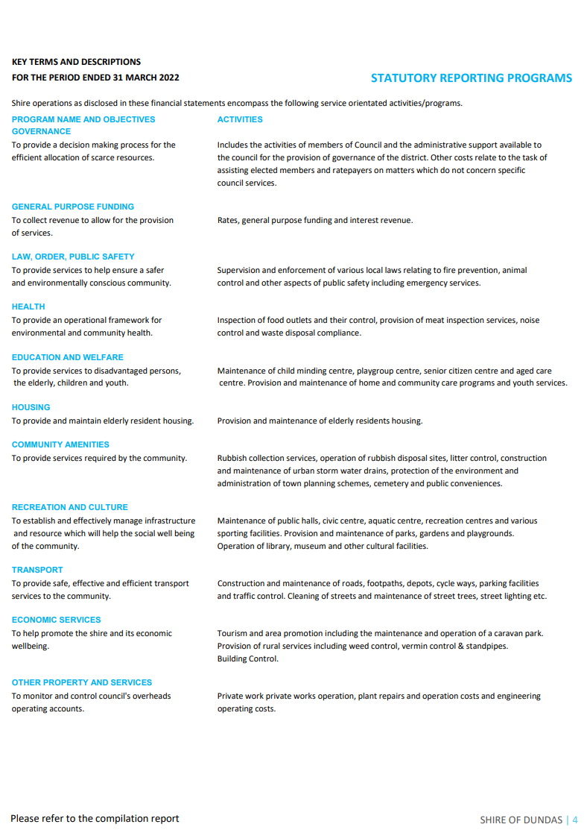
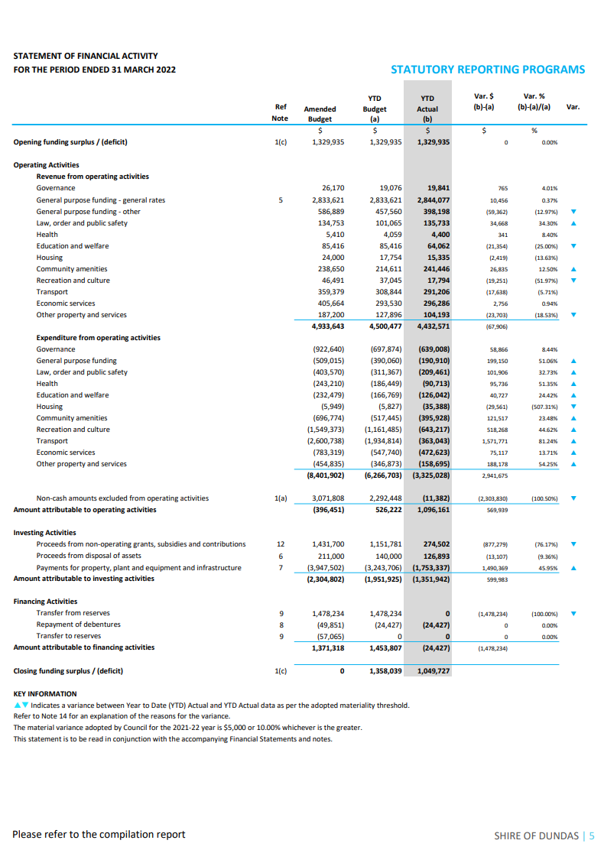
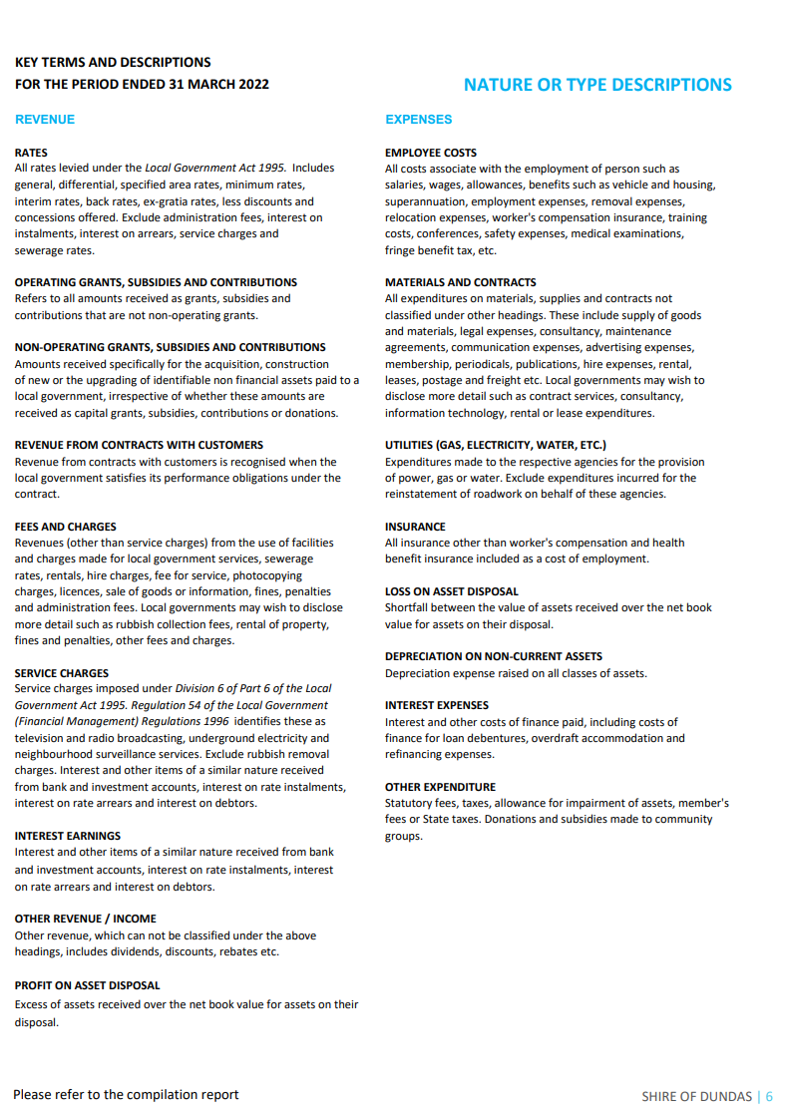
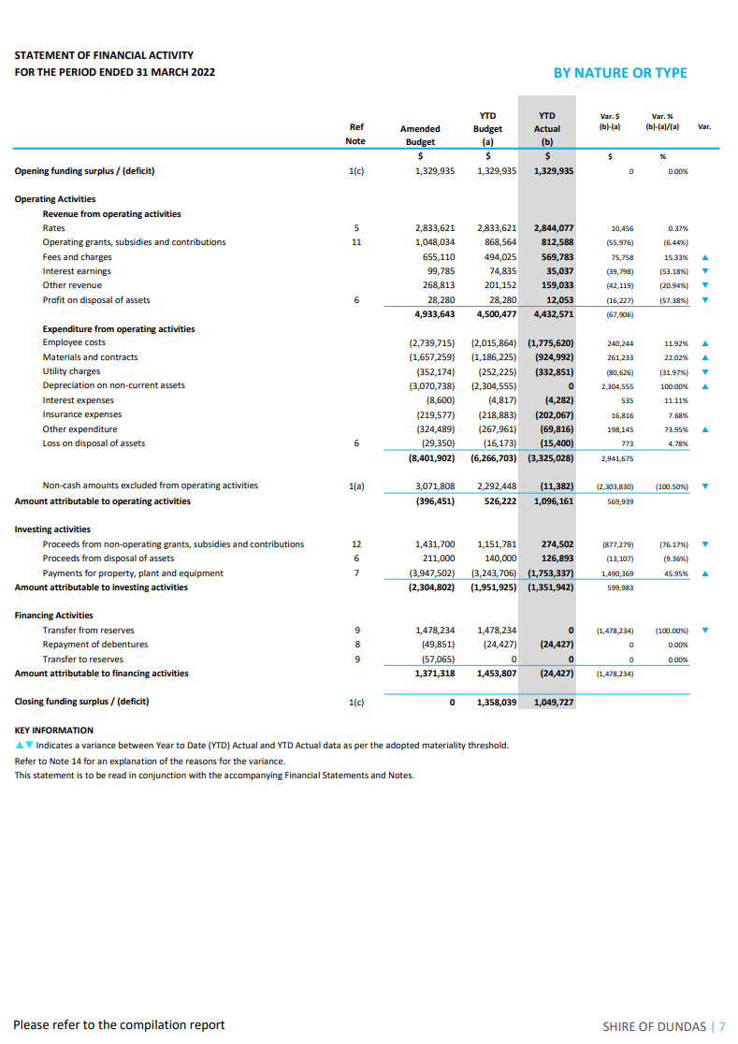
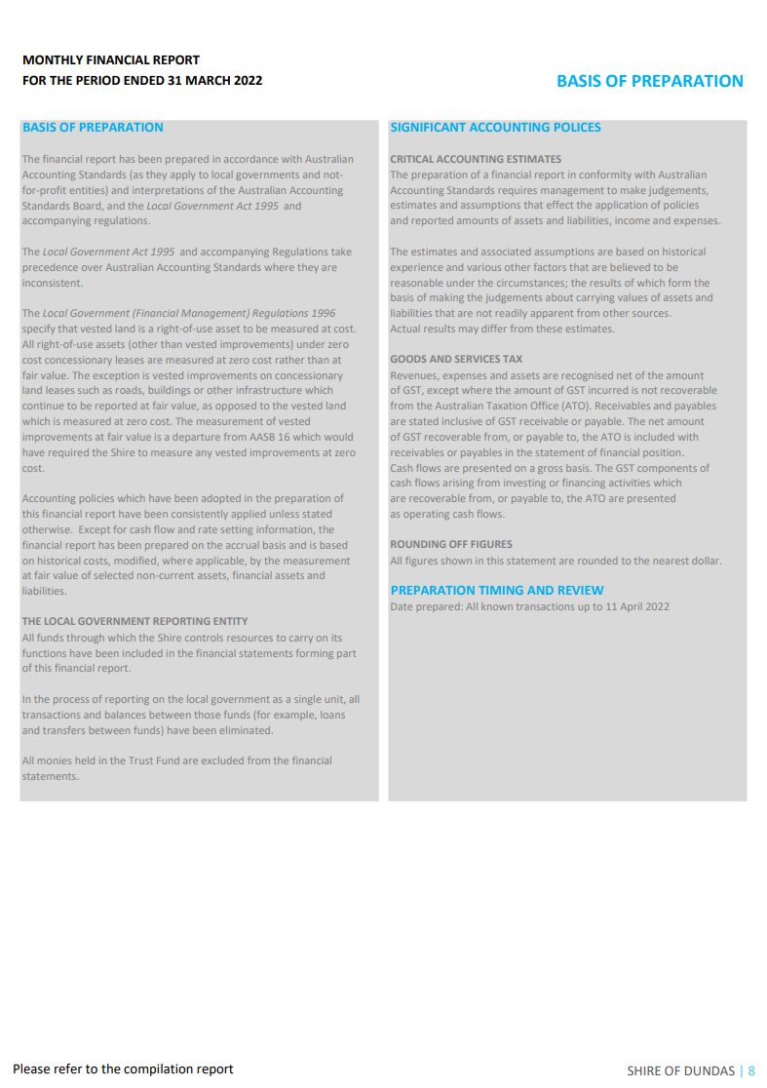
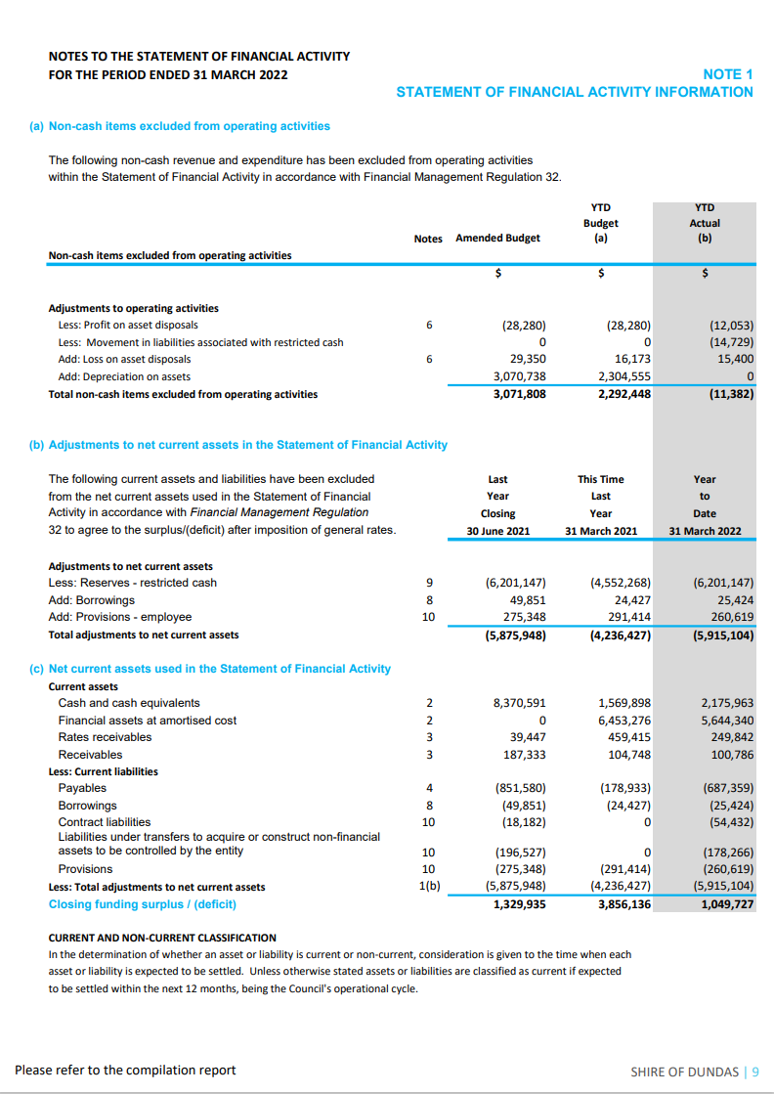
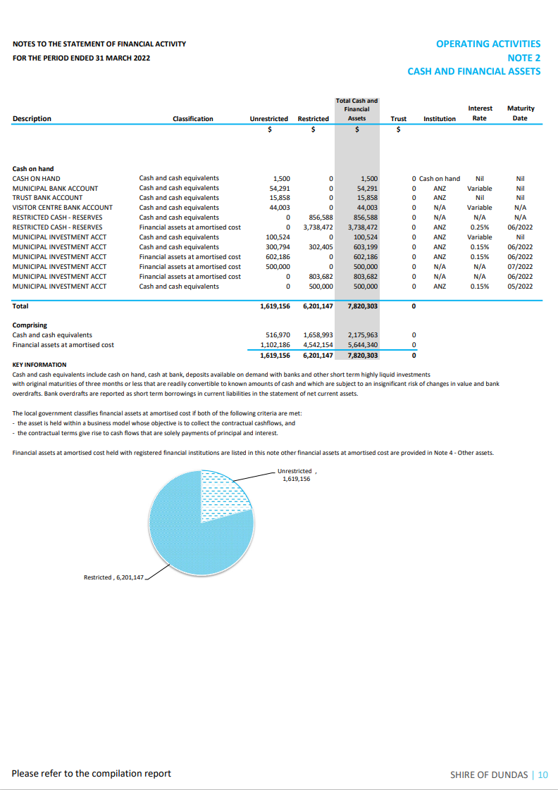
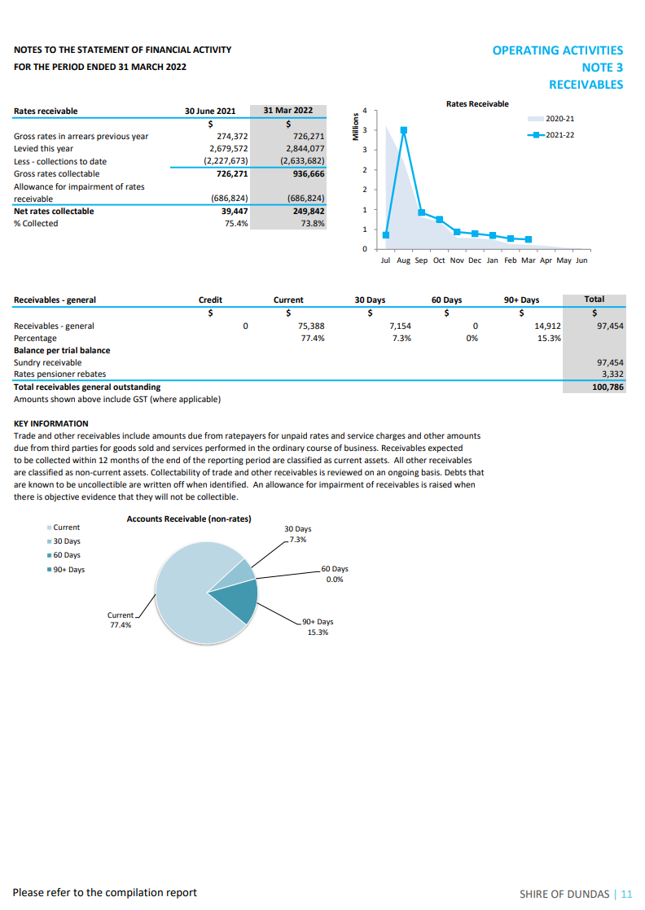
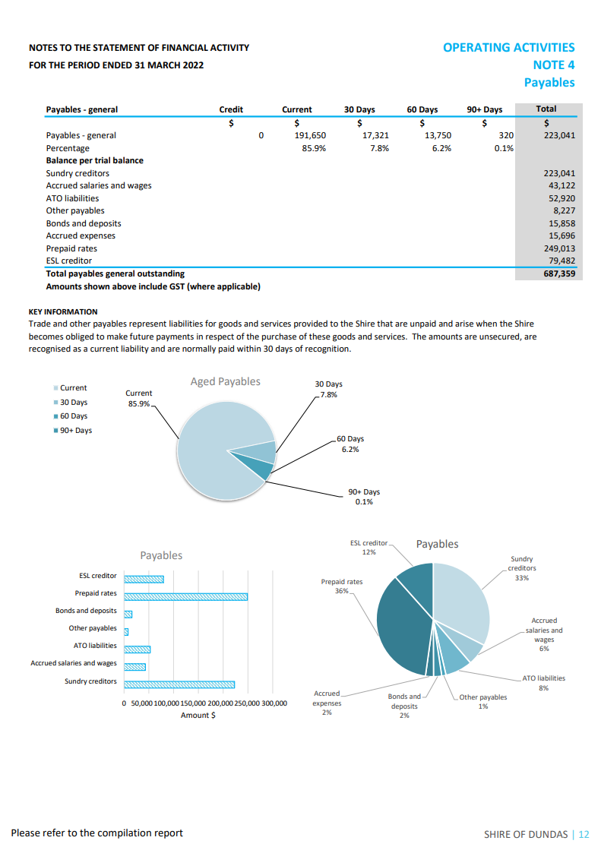
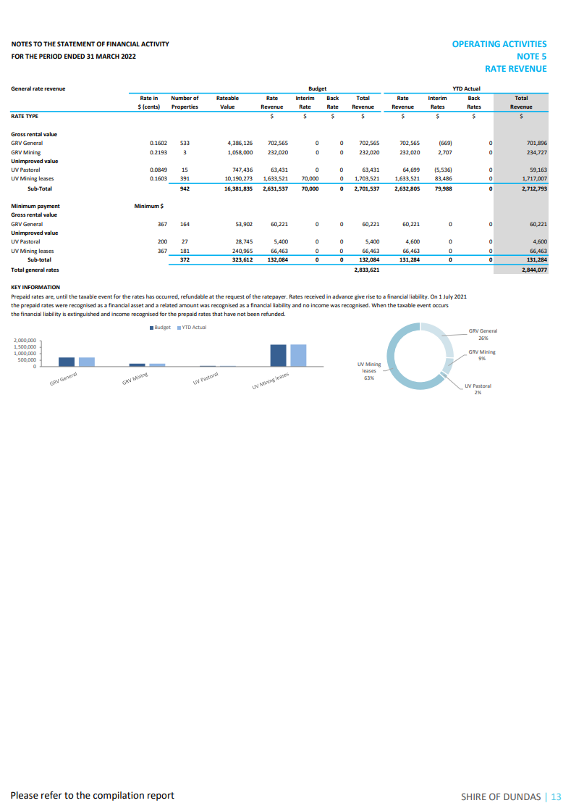
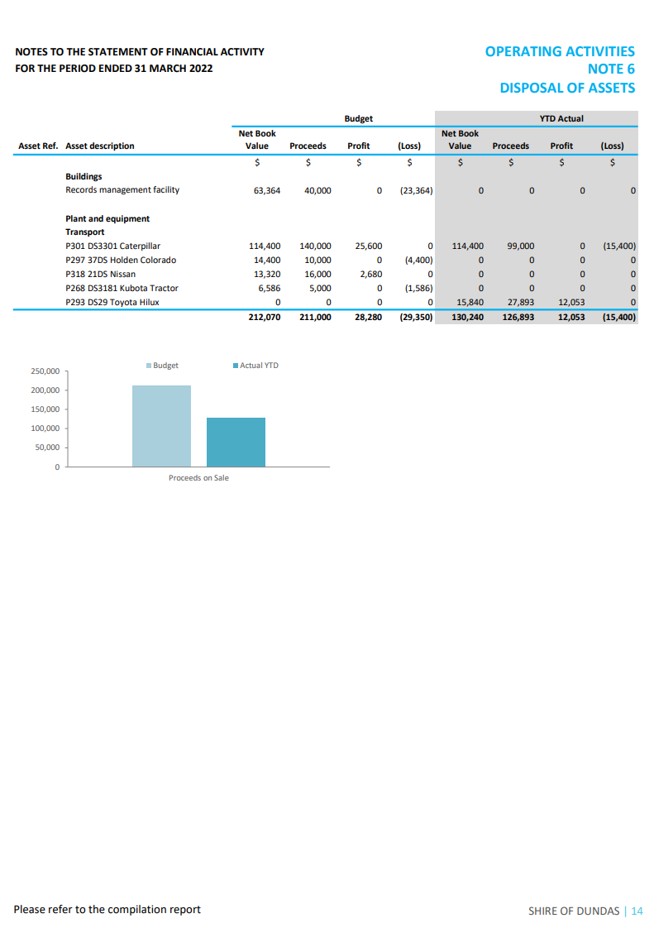
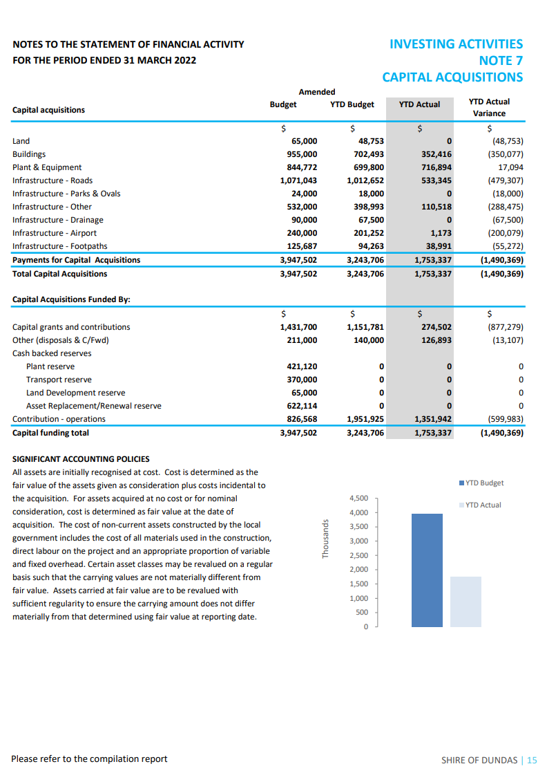
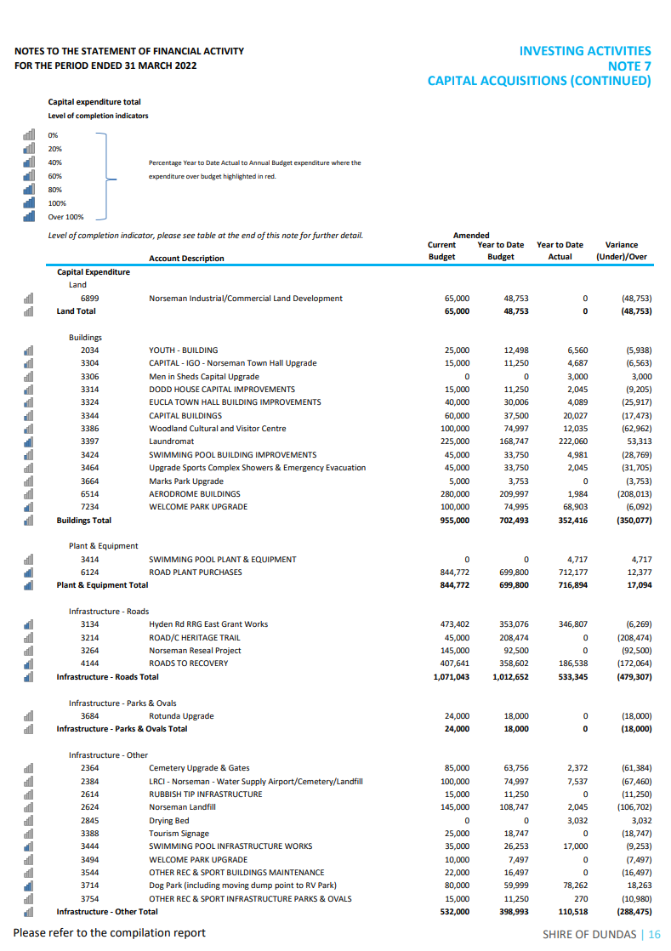
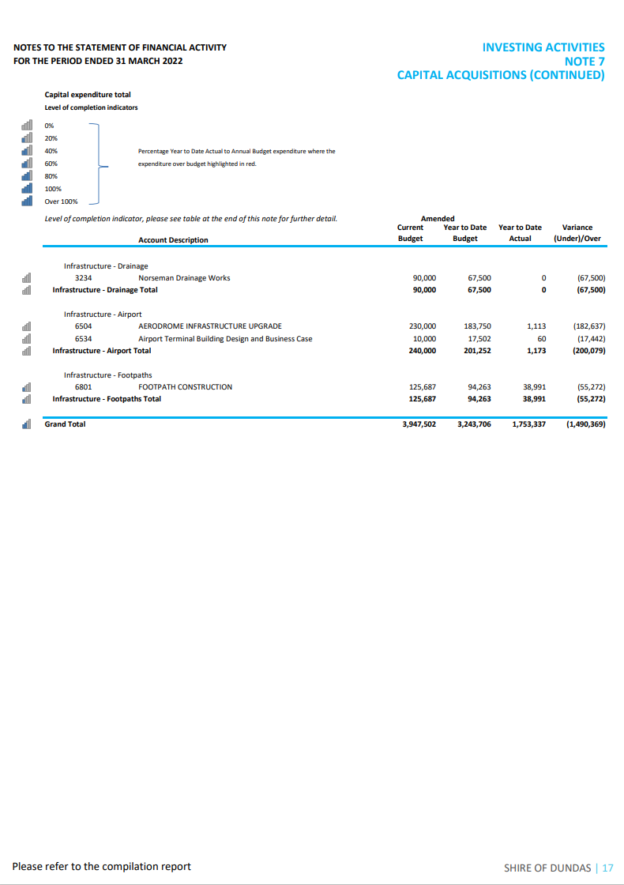
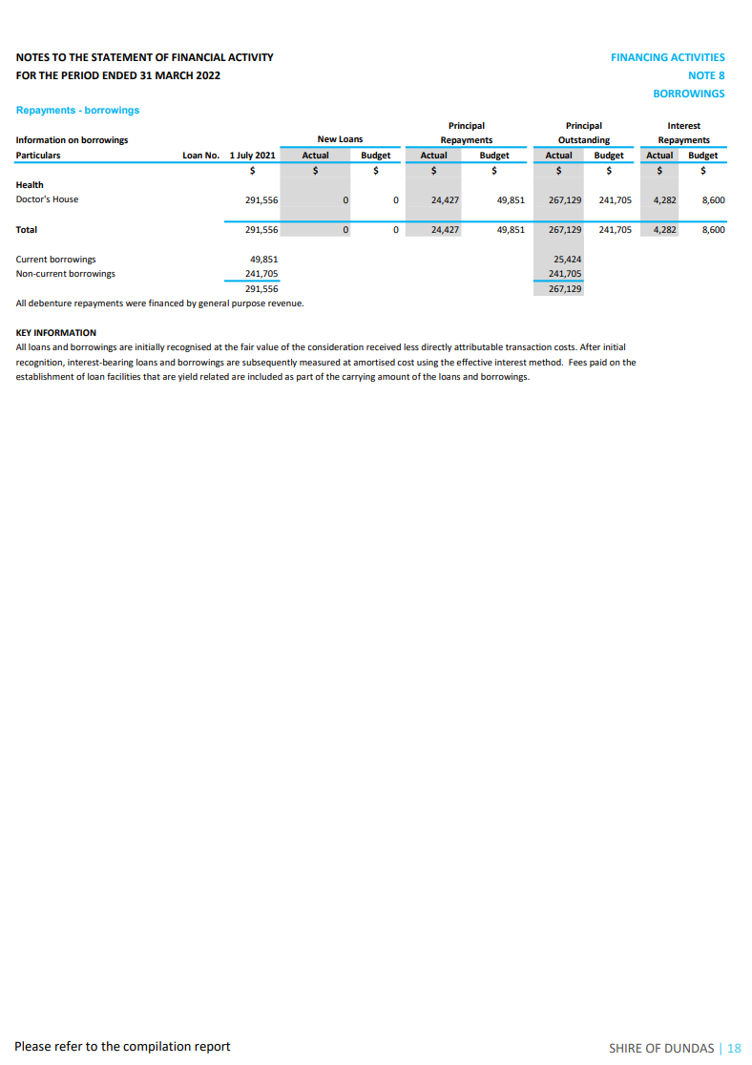
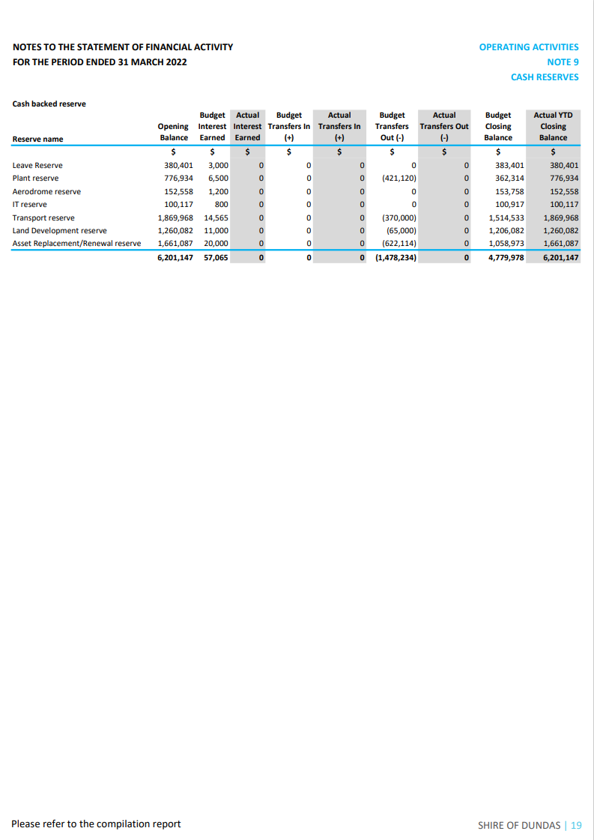
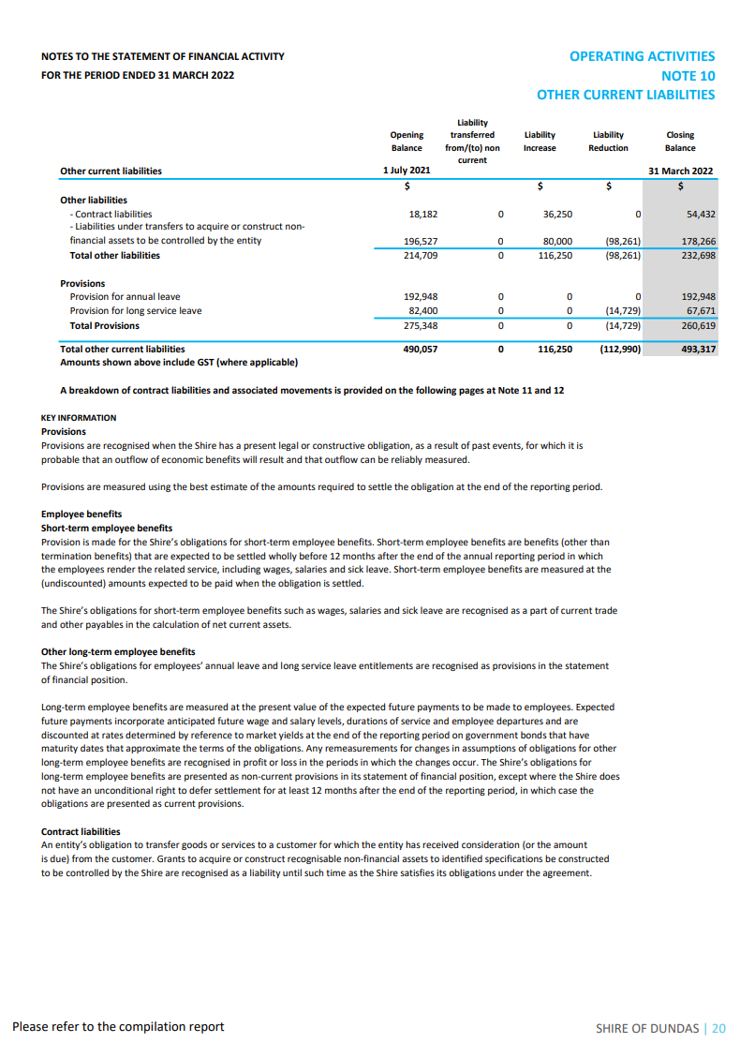
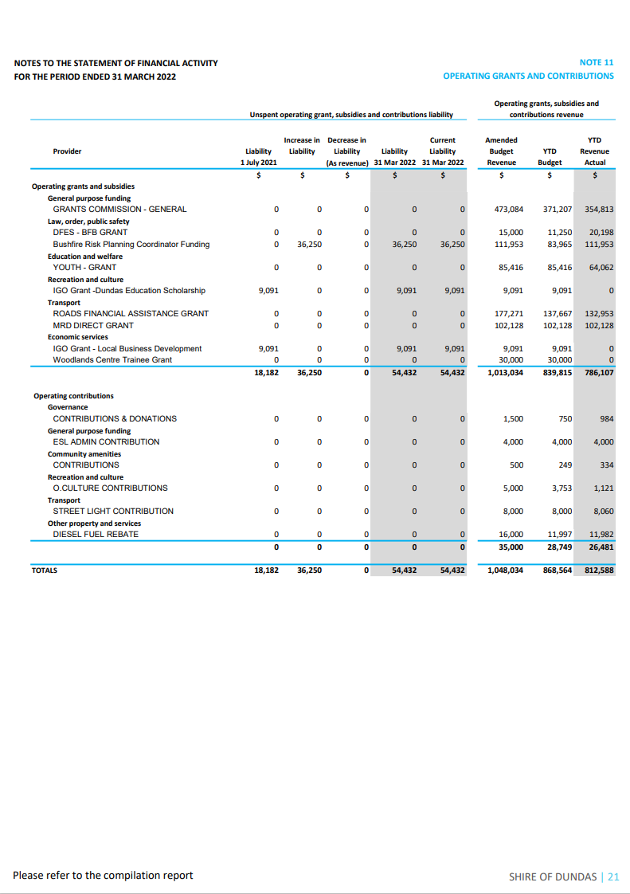
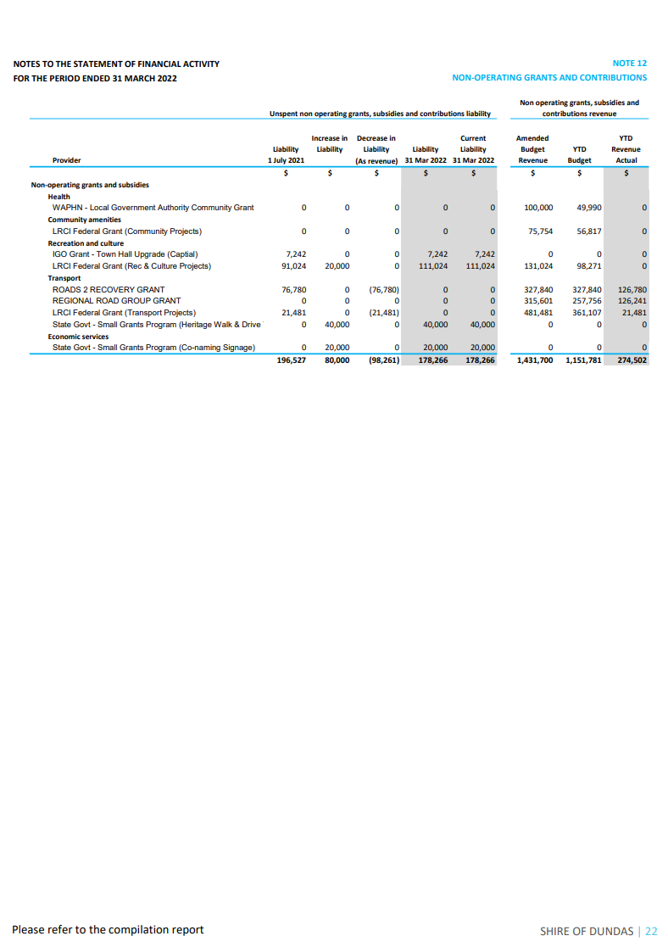
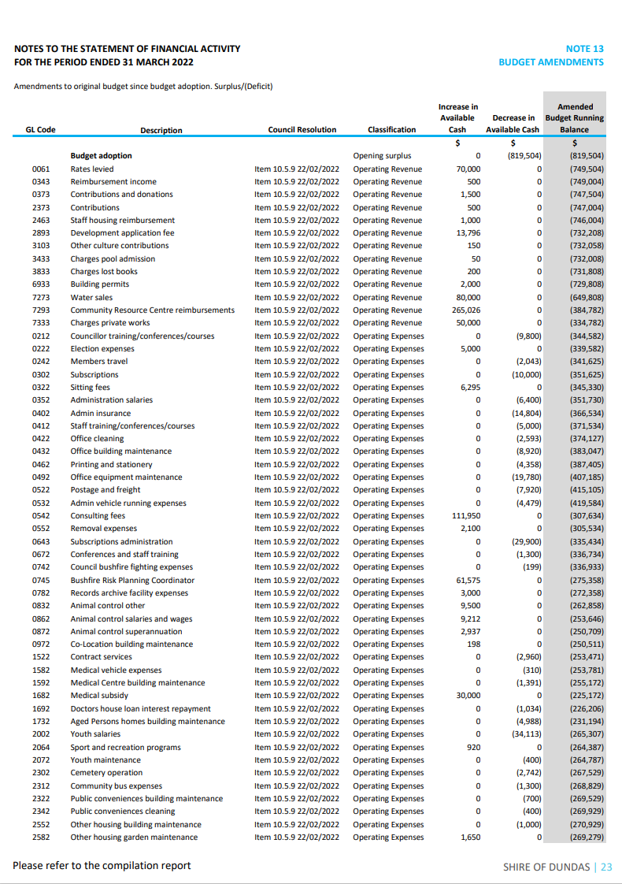
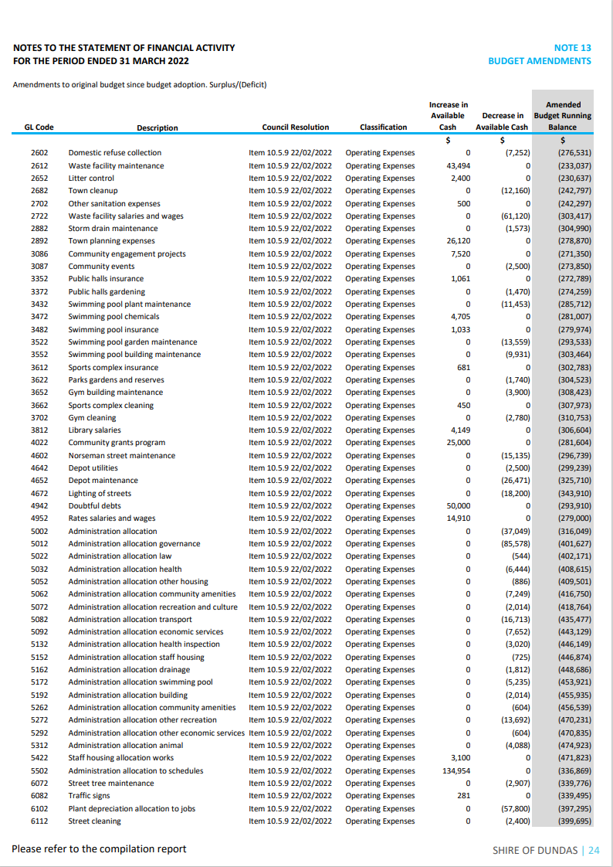
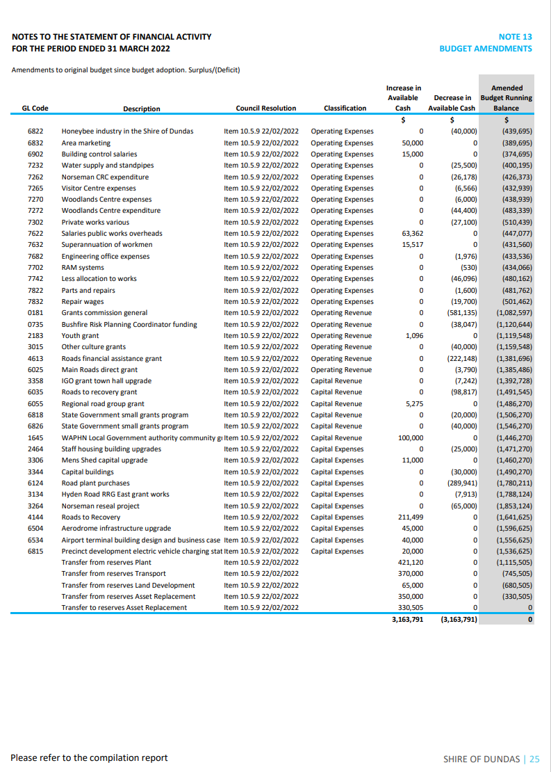
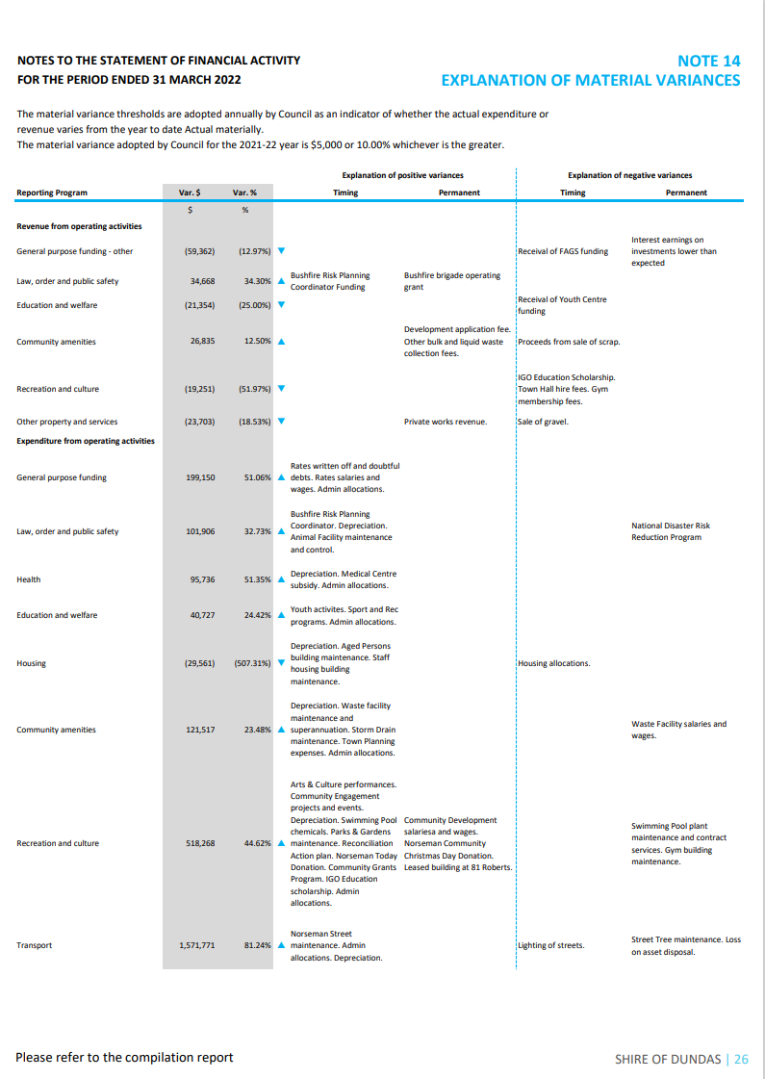
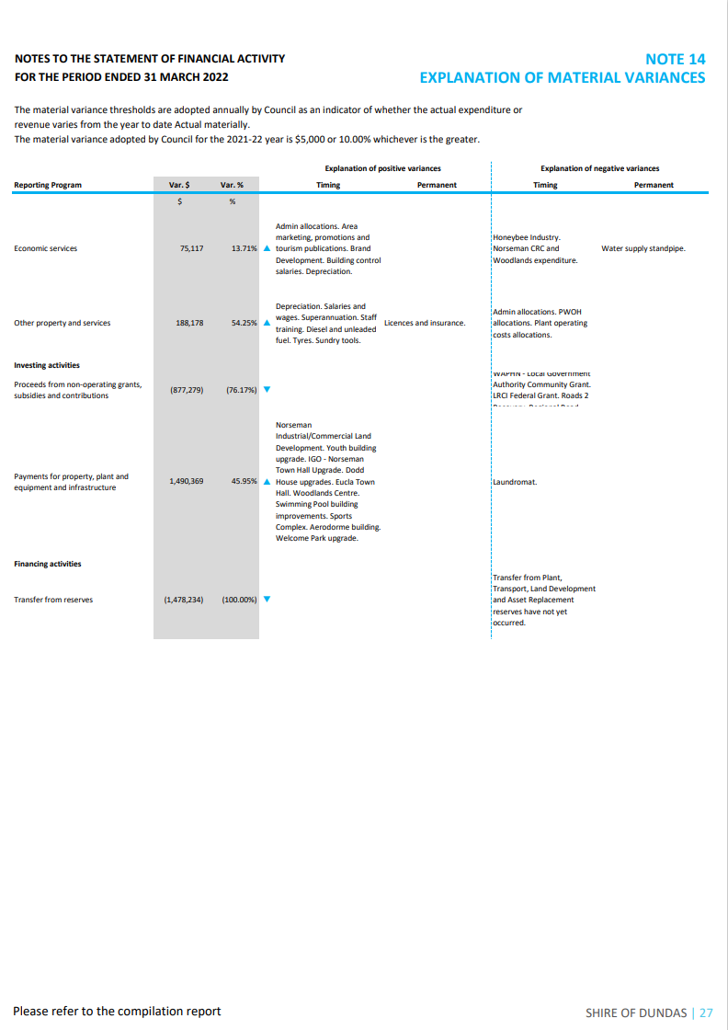

Voting Requirements

Simple Majority

Officer Recommendation

That the Shire of Dundas Financial Statements for the period ending 31 March 2022 be accepted.

Moved: Cr. Wyatt
Seconded: Cr. Hogan

Resolution

That the Shire of Dundas Financial Statements for the period ending 31 March 2022 be accepted.

Carried by: Simple Majority For: 6 Against: 0

Agenda Reference & Subject

10.4.1 – Officers Reports
Location / Address | Shire of Dundas
File Reference | CM.PL.1
Author | Chief Executive Officer – Peter Fitchat
Date of Report | 13 April 2022
Disclosure of Interest | Nil

Summary

That the Council receive the Works and Services, Corporate and Community Services, Tourism and Events Reports as contained in Papers Relating.

Background

The Officers present their reports on activities for the past month. These reports are in papers relating.

Statutory Environment

Shire officers are required to deliver the activities, programs, works and services within the appropriate legislative requirements where applicable.

Policy Implications

Shire officers are required to deliver the activities, programs, works and services guided by and within the appropriate Shire policies and procedures where applicable.

Financial Implications

Shire officers are required to deliver the activities, programs, works and services within allocated budgets, and purchasing and procurement policies.

Strategic Implications

Shire officers deliver activities, programs, works and services to achieve the community outcomes identified within the Strategic Community Plan.

Consultation
CEO
Manager of Corporate and Community Services
Acting Manager of Works and Services
Tourism and Events Officer

Comment

The reports will advise councillors of the progress being made towards achieving the objectives of the Strategic Plan.

Voting Requirements

Simple Majority

Officer Recommendation

That the Shire of Dundas Council receive the Corporate and Community Services, Works and Services, and Tourism and Events Reports as contained in Papers Relating.

Moved: Cr. Wyatt
Seconded: Cr. Hogan

Resolution

That the Shire of Dundas Council receive the Corporate and Community Services, Works and Services, and Tourism and Events Reports as contained in Papers Relating.

Carried by: Simple Majority For: 6 Against: 0

11. Elected Members Motions of Which Previous Notice Has Been Given

11.1 New Business of an Urgent Nature Introduced by the President or by a decision of the Meeting

No following items of urgent business were accepted for consideration by the President or by majority of the members of the Council.

12. Next Meeting

The next Ordinary Meeting of the Council is scheduled to be held at 6pm on the 17th of May 2022, in Norseman.

13. Closure of Meeting

There being no further business the Shire President will declare the meeting closed at: 6:28 PM.

