APPENDIX 7

Maps of the District

SHIRE OF DUNDAS – SHIRE BOUNDARIES, HIGHWAYS & RAILWAY

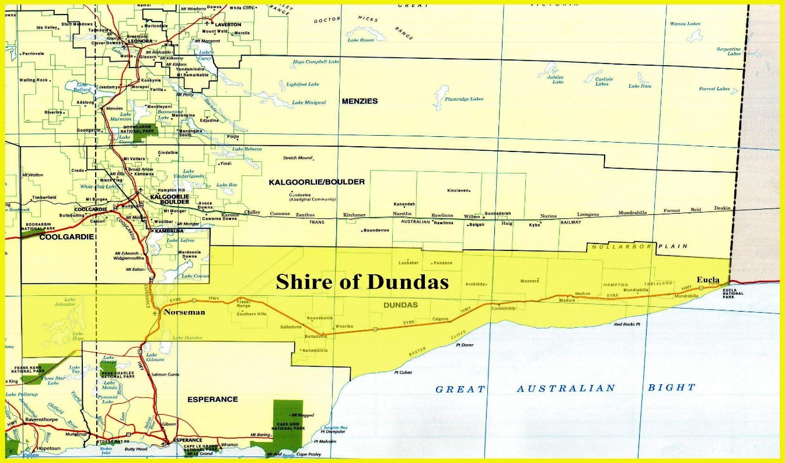

SHIRE OF DUNDAS – STREET MAP OF NORSEMAN WITH COMMUNITY HALL EVACUATION CENTRE

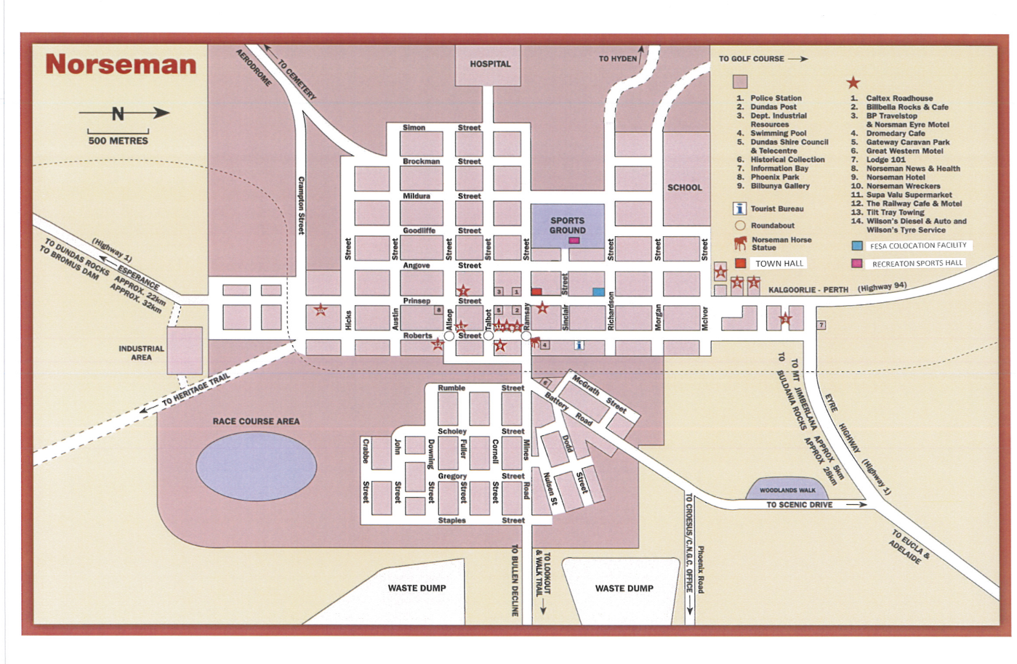

SHIRE OF DUNDAS – STREET MAP OF EUCLA WITH COMMUNITY HALL EVACUATION CENTRE

